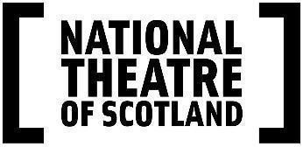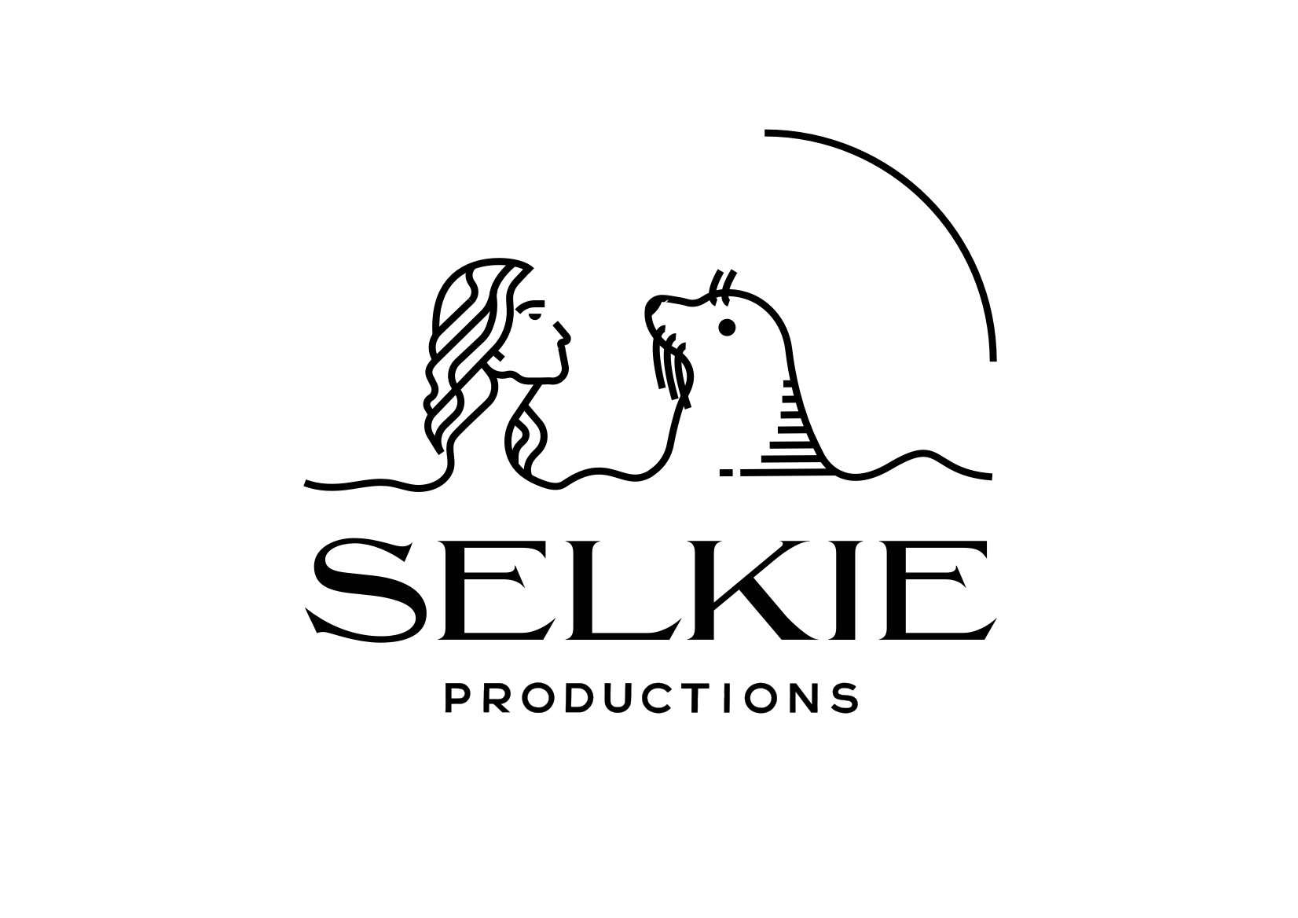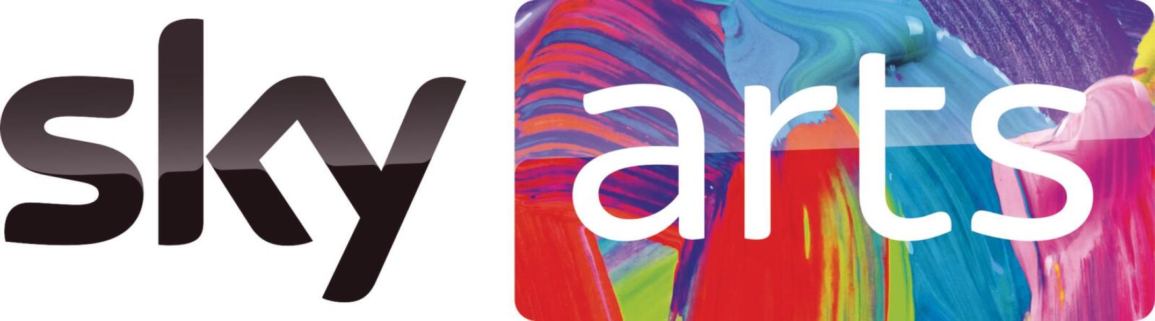

Press Release - 18 January 2022
CASTING ANNOUNCEMENT

The Strange Case of Dr Jekyll and Mr Hyde
Live at Leith Theatre and streaming to UK cinemas from February 2022
Feature film and Sky Arts TV presentation in 2023
Conceived and directed by Hope Dickson Leach.

Leading Scottish actors Lorn Macdonald and Henry Pettigrew will take on the roles of Utterson and Dr Jekyll supported by Tam Dean Burn, Caroline Deyga, Lois Hagerty, David Hayman, Scott Miller, Alison Peebles, Peter Singh and Ali Watts.

A unique theatrical live screen experience, and new feature film, conceived and directed by Edinburgh filmmaker Hope Dickson Leach.

- 25, 26 and 27 February 2022: A theatrical live experience at Leith Theatre
- 27 February 2022: ‘As live’ stream to selected Scottish/UK cinemas.
- Week of 28 February 2022: Encore screenings in UK cinemas.
- Autumn 2023: Edited feature film broadcast on Sky Arts.
- Press Images available here Dropbox
________________________________________________________________________

National Theatre of Scotland and Selkie Productions in association with Screen Scotland and Sky Arts present

The Strange Case of Dr Jekyll and Mr Hyde - Live at Leith Theatre
Conceived and directed by Hope Dickson Leach
Written by Hope Dickson Leach and Vlad Butucea
Based on the iconic novella by Robert Louis Stevenson.

Cinematographer David Liddell, Music Hudson Mohawke
Costume Designer Alisa Kalyanova, Sound Designer Ania Przygoda,
Production Designer Stephen Bryce, Editor Rachel Erskine

Cast includes:Tam Dean Burn, Caroline Deyga, Lois Hagerty, David Hayman, Lorn MacDonald, Scott Miller, Henry Pettigrew, Alison Peebles, Peter Singh and Ali Watts

Supported by Weston Culture Fund, Sir Ewan and Lady Brown, The Foyle Foundation, The Britford Bridge Trust, The William Syson Foundation, The Woolbeding Charity
The Strange Case of Dr Jekyll and Mr Hyde is a thrilling new hybrid version of Robert Louis Stevenson’s classic story, conceived and directed by Hope Dickson Leach, adapted from the original novella and relocated from London to Edinburgh. Presented by the National Theatre of Scotland and Selkie Productions in association with Screen Scotland and Sky Arts, this unique new retelling uses innovative theatrical and cinematic techniques to create a live filmic and theatrical experience. Entering a live filmset built within the atmospheric setting of Edinburgh’s historic Leith Theatre, audiences will witness the simultaneous creation and screening in this one-off experience.

Following the final performance on 27 February 2022. The Strange Case of Dr Jekyll and Mr Hyde will be livestreamed to selected Scottish cinemas. The show will then be screened ‘as live’ during the week of 28 February in UK cinemas. The footage captured during the performances will subsequently be edited into a full feature film, which will be broadcast on Sky Arts in 2023. This will be the first livestream film, created and set in Scotland, to be seen by audiences in Scottish cinemas. Theatrical rights have been acquired by leading film distributor Cosmic Cat, who will be streaming the performance into cinemas across Scotland and the UK.

A cast featuring leading Scottish stage and screen talent has been assembled for this unique project. BAFTA Scotland award winning Scottish actor Lorn Macdonald takes on the role of Utterson. Lorn won the Best Actor Scottish BAFTA award for his portrayal of Spanner in the film Beats. His roles on TV include Bridgerton, Deadwater Fell and Shetland. He has also recently been noted as one of the top 25 theatremakers to look out for in 2022 by The Stage. Dr Jekyll is performed by Scottish actor Henry Pettigrew. Henry’s screen roles include The Danish Girl as well as TV series The Crown and Guilt. He has appeared in previous National Theatre of Scotland productions Midsummer, Black Watch and Beautiful Burnout. They are both joined by Scottish stage and TV stalwart David Hayman who is playing the role of Sir Danvers Carew. David is a well know actor and director with recent film credits including In Like Flynn and Our Ladies. Peter Singh (Lanyon) has a prolific career on stage and screen, with recent film roles including Cruella and on TV, The Capture I and II (BBC) and Hard Cell (Netflix).

Alison Peebles (Poole) is an award-winning Scottish actor, writer and director. Her film work includes Where Do We Go From Here and Seven Lucky Gods and her TV work spans CBeebies hit Molly and Mack and River City. Tam Dean Burn (Councillor Begg) is a well known Scottish actor whose recent screen work includes Annika, Victim and Trust Me. Ali Watt (Inspector Hay) has most recently been seen on television in Irvine Welsh’s Crime and onstage at Pitlochry Festival Theatre in several productions including About Love. Scott Miller’s (Tennant) most recent credits include feature film The Road Dance and the tour of Warhorse and The Wife of Willesden at the Kiln Theatre, London, Caroline Deyga (Mabel) has most recently been seen on stage in The Importance of Being Earnest and with the National Theatre in Peter Gynt. She appeared in Our Ladies of Perpetual Succour for the National Theatre of Scotland.

The Strange Case of Dr Jekyll and Mr Hyde by Hope Dickson Leach and Vlad Butucea, returns to Edinburgh born writer Robert Louis Stevenson’s original story which was published in 1886. This gripping new adaptation has been developed with theatre dramaturg Rosie Kellagher. The drama follows Gabriel Utterson as he enters a world of dark duplicity to uncover the identity of the mysterious Mr Hyde and the hold he has over Utterson’s old friend Dr Jekyll.

In this version, Utterson’s journey is set against the background and backdrop of Victorian Edinburgh, where the wealth of the breweries is contrasted with the poverty of the Cowgate Vaults, exposing an underbelly of dark truths and corruption. Concerned by his good friend Dr Henry Jekyll’s recent behaviour, Gabriel Utterson is driven to uncover the identity of the mysterious and dangerous Mr. Hyde, to whom Jekyll is enthralled. Whilst on this search for the truth, Utterson finds himself seduced by the society of Edinburgh’s rich and powerful, but beneath the glossy façade lies a grim and brutal reality. This is a Jekyll and Hyde reworked for a contemporary audience with the themes of power, class and masculinity brought to the fore.

Embracing the duality of the storyline and the period authenticity, the film will be shot in black and white. Both the film and live event will feature new electronic music by DJ and music producer Hudson Mohawke, acclaimed for his genre-smashing" creative approach.

Hope Dickson Leach is an award-winning film maker, based in Edinburgh, whose debut film, The Levelling won her a Scottish BAFTA and the inaugural IWC Filmmaker Bursary Award in association with the BFI. This is her second project with the Company, she also co-conceived and directed Ghost Light with National Theatre of Scotland in association with Selkie Productions. This project reunites her with Vlad Butucea, (one of the writers for the National Theatre of Scotland’s Interference project) and contributing writer on Ghost Light.

The Strange Case of Dr Jekyll and Mr Hyde offers audiences the opportunity to experience a film being created around them, gaining insight into the theatre and filmmaking process. Audience members will wear headsets while watching the drama unfold live on a large screen in the auditorium.

A gothic tale of double lives and inner demons, the storyline is mirrored not only in the hybrid format of the production but in the audience experience at the venue, where they will be able to enjoy bespoke cocktails from the Jekyll and Hyde theatre bars.

Leith Theatre is a legendary music venue, performance space and community resource in the heart of Leith, which was a gift from the City of Edinburgh in the 1920s. Its main auditorium has played host to sporting events, the Edinburgh International Festival and iconic artists and bands. Currently closed to the public, audiences will have exclusive access to the main auditorium during the theatrical film event, and the venue’s historic backstage maze of rooms and hallways will be transformed into film set location scenes of Victorian Edinburgh.

The very first film version of Stevenson’s novel is believed to be a 16-minute-long silent horror film of Dr Jekyll and Mr Hyde made in 1908, based on a stage play. Since then, there have been over 123 films made, from animation to satire to horror, with versions filmed across the world.

The Strange Case of Dr Jekyll and Mr Hyde sees National Theatre of Scotland collaborating again with Selkie Productions and producer Wendy Griffin following the success of Ghost Light.
Screen Scotland’s support is funded through the Scottish Government and The National Lottery.

This hybrid production is part of the National Theatre of Scotland’s growing On Screen programme which includes content for digital, broadcast and cinemas including its series of short theatrical artworks, Scenes for Survival and Ghost Light, a celebration of theatre on film which was also made by award-winning film director Hope Dickson Leach. National Theatre of Scotland and Hopscotch Film’s special filmed version of Adam commissioned for BBC Scotland and BBC Arts which tells the remarkable story of a young trans man and his struggle across genders and borders to be himself is currently freely available to watch on BBC iPlayer until early 2022. The digital production won the Audience Award for Best Film at the Vancouver Queer Film Festival earlier this year and most recently won the award for Best Scripted TV in this year’s Scottish BAFTA’s.
Live at Leith Theatre:
Dates: 25 to 27 February 2022 at 7pm
Booking Information: www.nationaltheatrescotland.com

All seats for the Live at Leith Theatre production have now been allocated however further production seats may be released closer to the performance date please check the National Theatre of Scotland website for more information.

Cinema Listings for The Strange Case of Doctor Jekyll and Mr Hyde – Live From Leith Theatre stream will be announced on 28 January.

Access: Audio described and captioned performances on Friday 25 February
and BSL interpreted performance on Sunday 27 February

27 February 2022, 7pm: ‘As live’ streamed in selected Scottish cinemas.
28 February – 05 March 2022: Encore screenings in UK cinemas"

NATIONAL THEATRE OF SCOTLAND PRESS OFFICE CONTACTS:

Jane Hamilton – Media and Communications officer – jane.hamilton@nationaltheatrescotland.com
M: +44 (0)7967 742491

Emma Schad – Head of Communications – emma.schad@nationaltheatrescotland.com
Tel: +44 (0)227 9016 M: +44 (0)7930 308018

Press Images available here - Dropbox

ARTIST BIOGRAPHIES
Hope Dickson Leach completed her MFA in filmmaking at Columbia University where she made three short films that played at festivals worldwide. While in New York she was assistant to Todd Solondz on his film PALINDROMES. Hope’s award-winning thesis film, THE DAWN CHORUS, was selected for Sundance, Edinburgh, London and many other festivals. Screen International made her a Star of Tomorrow and Filmmaker Magazine named her one of the ’25 New Faces of Independent Film’. Since her return to the UK, she has made further acclaimed short works for Channel 4, Film London, the UK Film Council, NOWNESS and the National Theatre of Scotland. Her debut feature THE LEVELLING, produced as part the iFeatures scheme (funded by BBC Films, the BFI and Creative England) had its world premiere at the Toronto International Film Festival in September 2016 before screening at festivals all over the world. At the London Film Festival she was awarded the inaugural IWC Filmmaker Bursary Award in Association with the BFI, and in October 2017 she was named a BAFTA Breakthrough Brit. She won a Scottish BAFTA for Best Screenwriter for The Levelling in November 2017. In 2020 she released a new short film, STRONG IS BETTER THAN ANGRY, as part of The Uncertain Kingdom project, and is currently developing several new feature films in the US and UK. In summer 2020 Hope created a film for the National Theatre of Scotland for the Edinburgh International Festival. GHOST LIGHT premiered to five star reviews across the board. Hope is a co-founder of Raising Films, a campaign to make the film industry more sustainable for parents and carers, and is a member of the new National Partnership for Culture in Scotland.

ACTORS BIOGS CAN BE VIEWED HERE – LINK TO WEBSITE

NOTES TO EDITORS
The National Theatre of Scotland is dedicated to playing the great stages, arts centres, village halls, schools and site-specific locations of Scotland, the UK and internationally. As well as creating ground-breaking productions and working with the most talented theatre-makers, the National Theatre of Scotland produces significant community engagement projects, innovates digitally and works constantly to develop new talent. Central to this is finding pioneering ways to reach current and new audiences and to encourage people’s full participation in the Company’s work. With no performance building of its own, the Company works with existing and new venues and companies to create and tour theatre of the highest quality. Founded in 2006, the Company, in its short life, has become a globally significant theatrical player, with an extensive repertoire of award-winning work. The National Theatre of Scotland is supported by the Scottish Government. www.nationaltheatrescotland.com

Leith Theatre is a Grade II listed building in Leith undergoing transformative change towards becoming a permanent cultural venue and a home in Scotland for live music and performance. It is in need of significant repair and preservation but even so, plays an important part in Leith’s history, having seen nearly 100 years of change and now being a driver of a future cultural quarter for the area.

- Live in Leith™ is the new production arm of Leith Theatre bringing in-house live music and performance programming to the venue. During Covid, it was pointed to deliver a digital programme, both to shine a spotlight on break-through Scottish talent and on the venue itself during a period of darkness.

- It is a building with a strong musical legacy, having played host to the likes of AC/DC, Kraftwerk and Thin Lizzy during the 70s; opera, theatre, and ballet through the 60-80s with notable mention of Yukio Ninagawa’s acclaimed ‘Samurai’ Macbeth in 1985; before suffering another significant period of closure of nearly 30 years until 2016. Since 2018, 1500 capacity audiences have been back through the doors and great music has been back on the stage, including The Snuts, Young Fathers, Kae Tempest, Jarvis Cocker, The Jesus and Mary Chain, Neneh Cherry, Mogwai and many more; reigniting the need for such a mid-sized music venue in Edinburgh.

- Leith Theatre is part of a 1930s Art Deco complex gifted to the people of Leith by the City of Edinburgh after the amalgamation of the two in 1920. The complex includes Leith Library, the Thomas Morton Hall and a small Gatehouse. This impressive building has seen both joyous celebration and darkest moments; hit by a bomb in 1941, it took 20 years to be repaired, only to be closed again in the 80s. The Trust took over in 2016 following community campaigning to save the building from private development and are now working to secure capital investment to ensure that this glorious semi-derelict building and important cultural asset is available and protected for future generations.

- Leith Theatre sits in the heart of an area currently undergoing significant coastal redevelopment and regeneration. It connects the North of the city with Edinburgh’s centre and brings important cultural programme to one of Timeout’s coolest neighbourhoods in the world as well as audiences further afield; local to international being its ethos. In recent years it has shown its importance as a destination venue for live music, an increasingly sought-after filming location and an important space for community driven initiatives and wellbeing; a unique place in the City of Edinburgh combining social and cultural value of scale.

- Leith Theatre has offered its exciting cultural programme for 5 years on a pop-up basis, working around the many limitations the space has; for one thing, it has never been watertight during this time. However, Leith Theatre Trust are now investment ready and about to embark on a planned capital fundraising campaign for 2022. To follow its journey, support its future development and ensure the protection of this historic cultural asset you can do so here….
For more information about Leith Theatre visit www.leiththeatre.co.uk
Follow Leith Theatre on Twitter @leiththeatre
On Facebook @leiththeatre
On Instagram @leiththeatre
To support Leith Theatre fundraising www.justgiving.com/leiththeatretrust
To speak to a member of the Leith Theatre team email: lynn.morrison@leiththeatre.co.uk
or call 07971 965475

Sky Arts exists to bring more art to more people across the UK. In 2020, with the creative industries under serious threat, we threw open our doors to make the channel free for everyone to watch. We’ve redoubled our mission to increase access to the arts and we’re committed to getting everyone involved as the industry recovers. The fact is, we need the arts now like never before, and Sky Arts brings them straight to your living room. We have something for everyone, championing creative talent by showcasing the best in music, theatre, dance, literature, opera and visual art. From Glyndebourne to Grime and Cézanne to The Style Council, we’ve got your passions covered. Millions of viewers tune in to hit returning series such as Portrait Artist of the Year, Urban Myths and British cultural institution The South Bank Show, but our acclaimed new programmes might take you anywhere from Pinter’s house with Danny Dyer to a Scottish road trip with Samuel Johnson. Collaboration is at the heart of what we do. Sky Arts is the headline sponsor of National Theatre Live in the UK and we work with cultural partners across the country including the English National Opera, Royal Academy of Arts, Tate, Creative Industries Federation and Coventry City of Culture to name but a few. You can watch Sky Arts for free on Freeview channel 11 and Freesat channel 147. If you’ve got Sky or a Now TV entertainment pass, you can also watch over 2,000 hours of shows exclusively on demand. We’re passionate about supporting the next generation of artists, so we’re working with five leading Sky Arts Ambassadors: Booker Prize-winner Bernardine Evaristo, dance artist Akram Khan, conductor Charles Hazlewood, Theatre Royal Stratford East Artistic Director Nadia Fall, and sculptor Anish Kapoor – to run bursary schemes for new and emerging talent.

