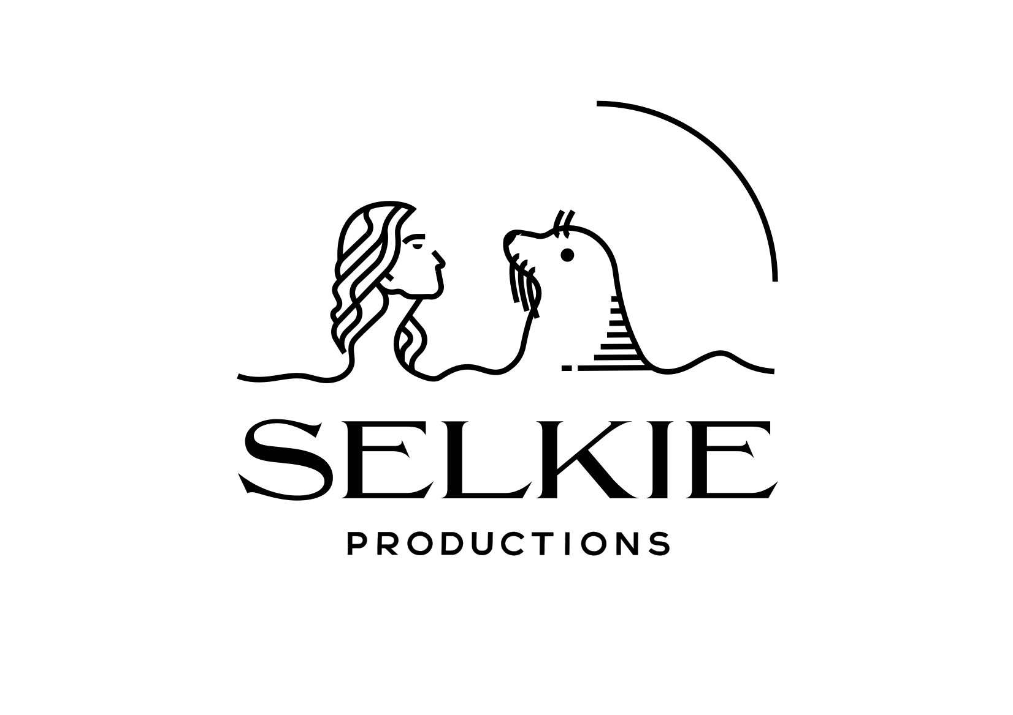

**National Theatre of Scotland and Selkie Productions**

**Supported by Screen Scotland and Sky Arts**

**present**

***The Strange Case of Dr Jekyll and Mr Hyde***

**A WORLD PREMIERE**

**at the EDINBURGH INTERNATIONAL FILM FESTIVAL**

**WITH PUBLIC SCREENINGS ON 21 AND 22 AUGUST**

**The film will subsequently be broadcast on Sky Arts later in 2023**

[**PR images here**](https://www.dropbox.com/sh/xpb1el1dtfqe0ty/AAArywAiXrI5k52jf54pBjxda?dl=0)

Directed by **Hope Dickson Leach,** Written by **Hope Dickson Leach** and **Vlad Butucea,** Based on the novella by **Robert Louis Stevenson.**

Cinematographer **David Liddell**, Music **Hudson Mohawke and Hutch Demouilpied**

Costume Designer **Alisa Kalyanova**, Sound Designer **John Cobhan,** Production Designer **Stephen Bryce** andEditors **Rachel Erskine** and **Aurora Vogelli**

Full cast: **Tam Dean Burn, Greg Miller Burns, Caroline Deyga, Lois Hagerty, David Hayman, Lorne Macdonald, Scott Miller, Alison Peebles, Henry Pettigrew, Peter Singh, Paul Tinto, Patrick Wallace and Ali Watt**

**Supported by**

**Garfield Weston Foundation, Sir Ewan and Lady Brown**, **The Foyle Foundation, The Britford Bridge Trust**, **The William Syson Foundation**, **The Woolbeding Charity**

***The Strange Case of Dr Jekyll and Mr Hyde***, director Hope Dickson Leach’s new version of Robert Louis Stevenson’s classic story, co-written with Vlad Butucea, will receive its world premiere at the Edinburgh International Film Festival in 2023. Adapted from the original novella and relocated from London to Edinburgh, this film is a National Theatre of Scotland and Selkie Productions supported by Screen Scotland and Sky Arts.

Filmed largely within the atmospheric setting of Edinburgh’s historic Leith Theatre, ***The Strange Case of Dr Jekyll and Mr Hyde*** was originally presented in February 2022 as a performed live, filmic experience in the venue.

The film will premiere at the Edinburgh International Film Festival on 21 & 22 August and

will be broadcast on Sky Arts (Freeview Channel 11) later this year.

Hope Dickson Leach –co- writer and director said

“*I’m totally delighted that our film The Strange Case of Dr Jekyll and Mr Hyde will be having its world premiere at the Edinburgh International Film Festival on 21 August.. For a project that is so profoundly centred in the city of Edinburgh, I can imagine no better place to share this Scottish film with the world. Relocating Stevenson’s iconic tale to the capital of Scotland allowed us to interrogate and expose some of the city’s buried history, an endeavour which deepened my knowledge of my hometown. In 2022 we performed and streamed the live show from the historic Leith Theatre to audiences in the auditorium and across the UK. Since then we have re-edited the material, shot new footage and composed new music to create the final film that we will be sharing with Edinburgh audiences for the first time in August. It is the perfect conclusion to the creative journey I feel so lucky to have been aboard*”

Embracing the duality of the storyline and the period authenticity, the film was shot in black and white. It features a cast of leading Scottish stage and screen talent and music by DJ and music producer Hudson Mohawke and composer Hutch Demouilpied (*Limbo*).

**Lorn Macdonald** takes on the role of Utterson. Lorn won the Best Actor Scottish BAFTA award for his portrayal of Spanner in the film *Beats.* His roles on TV include *Bridgerton, Deadwater Fell* and *Shetland.* He was noted as one of the top 25 theatre-makers to look out for in 2022 by The Stage. Dr Jekyll is performed by Scottish actor **Henry Pettigrew**. Henry’s screen roles include *The Danish Girl* as well as TV series *The Crown* and *Guilt*. He has appeared in previous National Theatre of Scotland productions *Midsummer*, *Black Watch* and *Beautiful Burnout*. They are both joined by Scottish stage and TV stalwart **David Hayman** who is playing the role of Sir Danvers Carew. David is a well know actor and director with recent film credits including *In Like Flynn* and *Our Ladies.* **Peter Singh** (Lanyon) has a prolific career on stage and screen, with recent film roles including *Cruella* and on TV, *The Capture I* and *II* (BBC) and *Hard Cell* (Netflix).

**Alison Peebles** (Poole) is an award-winning Scottish actor, writer and director. Her film work includes *Where Do We Go From Here* and *Seven Lucky Gods* and her TV work spans CBeebies hit *Molly and Mack* and *River City*. **Tam Dean Burn** (Councillor Begg) is a well-known Scottish actor whose recent screen work includes *Annika*, *Victim* and *Trust Me*. **Ali Watt** (Inspector Hay) has most recently been seen on television in Irvine Welsh’s *Crime* and onstage at Pitlochry Festival Theatre in several productions including *About Love.* **Scott Miller**’s (Tennant) most recent credits include feature film *The Road Dance* and the tour of *Warhorse* and *The Wife of Willesden* at the Kiln Theatre, London, **Caroline Deyga** (Mabel) has most recently been seen on stage in *The Importance of Being Earnest* and with the National Theatre in *Peter Gynt*. She appeared in *Our Ladies of Perpetual Succour* for the National Theatre of Scotland.

***A gothic tale of double lives and inner demons.***

***The Strange Case of Dr Jekyll and Mr Hyde*** by Hope Dickson Leach and Vlad Butucea, returns to Edinburgh born writer Robert Louis Stevenson’s original story which was published in 1886. The drama follows Gabriel Utterson as he enters a world of dark duplicity to uncover the identity of the mysterious Mr Hyde and the hold he has over Utterson’s old friend Dr Jekyll.

In this version, Utterson’s journey is set against the background and backdrop of Victorian Edinburgh, where the wealth of the breweries is contrasted with the poverty of the Cowgate Vaults, exposing an underbelly of dark truths and corruption. Concerned by his good friend Dr Henry Jekyll’s recent behaviour, Gabriel Utterson is driven to uncover the identity of the mysterious and dangerous Mr. Hyde, to whom Jekyll is enthralled. Whilst on this search for the truth, Utterson finds himself seduced by the society of Edinburgh’s rich and powerful, but beneath the glossy façade lies a grim and brutal reality. This is a Jekyll and Hyde reworked for a contemporary audience with the themes of power, class and masculinity brought to the fore.

Hope Dickson Leach is an award-winning film maker, based in Edinburgh, whose debut film, *The Levelling* won her a Scottish BAFTA and the inaugural IWC Filmmaker Bursary Award in association with the BFI.

Hope Dickson Leach first worked with the National Theatre of Scotland during lockdown in August 2020, when she made *Ghost Light,* a love letter to Scottish theatre, for digital platforms, as part of the Edinburgh International Festival’s My Light Shines On festival. Following on from this collaboration and with lockdown continuing to affect live performance,  Hope began to develop this theatre/film hybrid version of *The Strange Case of Dr Jekyll and Mr Hyde*, for National Theatre of Scotland and Selkie Productions (who also worked on *Ghost Light*) with the project going on to receive support from Screen Scotland and Sky Arts.

Leith Theatre offers the perfect backdrop to film. The venue’s historic backstage maze of rooms and hallways and outside facades were transformed into film set location scenes of Victorian Edinburgh. Other scenes were filmed on location around Edinburgh.

Leith Theatre is a legendary music venue, performance space and community resource in the heart of Leith, which was a gift from the City of Edinburgh in the 1920s. Its main auditorium has played host to sporting events, the Edinburgh International Festival and iconic artists and bands.

The very first film version of Stevenson’s novel is believed to be a 16-minute-long silent horror film of *Dr Jekyll and Mr Hyde* made in 1908, based on a stage play. Since then, there have been over 123 films made, from animation to satire to horror, with versions filmed across the world.

Screen Scotland’s support is funded through the Scottish Government and The National Lottery.

This film is part of the National Theatre of Scotland’s growing On Screen programme which includes content for digital platforms and broadcast. Recent highlights include National Theatre of Scotland and Hopscotch Film’s special filmed version of *Adam* commissioned for BBC Scotland and BBC which won the Audience Award for Best Film at the Vancouver Queer Film Festival and Best Scripted TV in the Scottish BAFTA’s 2021.

Edinburgh based production company Selkie Productions was set up by Wendy Griffin in 2014 to develop a slate of film and TV projects. Selkie produced Hope Dickson Leach’s short *Stronger is Better than Angry* and Wendy Griffin was producer on *Ghost Light* for National Theatre of Scotland and EIF. Recently Wendy co- produced 'The Origin' which just premiered at LFF and was co producer on Stephen Frears 'The Lost King' and Charlotte Colbert's 'She Will'. Selkie has several projects in development with Screen Scotland and BFI.

**Timeline/background -  the making of The Strange Case of Dr Jekyll and Mr Hyde**

2021 - Development begins for innovative project to deliver a live theatrical experience for a pandemic audience

February 2022 - Live mixed performances at Leith Theatre and live cinema stream across UK cinemas

October 2022 – Additional shooting of new material with cast on location in Edinburgh

Early 2023  - Edit of live and newly filmed material, new music and sound design composed and mixed.

August 2023 – World premiere of final feature film at Edinburgh International Film Festival

Autumn 2023 -  Broadcast premiere of feature film on Sky Arts

**SCREENING DETAILS at EDINBURGH INTERNATIONAL FILM FESTIVAL**

21 August 2023  at 18:00  Everyman 1

22 August 2023  at 14.30 Vue 10

**PRESS SCREENING**

21 August 2023 at 9.00 Vue 10

[**https://www.eif.co.uk/edfilmfest**](https://www.eif.co.uk/edfilmfest)

_________________________________________________________________________

**EIFF press contact:**

**Chris Boyd -** chris@thecornershoppr.com

**NATIONAL THEATRE OF SCOTLAND PRESS OFFICE CONTACTS:**

**Emma Schad – Head of Communications** - [emma.schad@nationaltheatrescotland.com](mailto:emma.schad@nationaltheatrescotland.com)         Tel: +44 (0)227 9016   M: +44 (0)7885998533

Jack Oliver **–** Media and Communications Officer- j[ack.oliver@nationaltheatrescotland.com](mailto:Jack.oliver@nationaltheatrescotland.com) Tel: +44 (0)7580132816

**Notes to Editors**

**The National Theatre of Scotland** is dedicated to playing the great stages, arts centres, village halls, schools and site-specific locations of Scotland, the UK and internationally. As well as creating ground-breaking productions and working with the most talented theatre-makers, the National Theatre of Scotland produces significant community engagement projects, innovates digitally, and works constantly to develop new talent. Central to this is finding pioneering ways to reach current and new audiences and to encourage people’s full participation in the Company’s work. With no performance building of its own, the Company works with existing and new venues and companies to create and tour theatre of the highest quality. Founded in 2006, the Company, in its short life, has become a globally significant theatrical player, with an extensive repertoire of award-winning work. The National Theatre of Scotland is supported by the Scottish Government. [www.nationaltheatrescotland.com](http://www.nationaltheatrescotland.com )

**Screen Scotland** drives development of all aspects of Scotland’s film and tv industry, through funding and strategic support.

Screen Scotland is part of Creative Scotland and delivers these services and support with funding from Scottish Government and The National Lottery. Find out more at [screen.scot](https://www.screen.scot/) and follow us on [Twitter](https://twitter.com/screenscots) and [Instagram](https://www.instagram.com/screenscots/).

**Sky Arts** exists to bring more art to more people across the UK. In 2020, with the creative industries under serious threat, we threw open our doors to make the channel free for everyone to watch. We’ve redoubled our mission to increase access to the arts and we’re committed to getting everyone involved as the industry moves from strength to strength. The fact is, we need the arts like never before, and Sky Arts brings them straight to your living room.

We have something for everyone, championing creative talent by showcasing the best in music, theatre, dance, literature, opera and visual art. From Glyndebourne to Grime and Nina Simone to Noel Gallagher, we’ve got your passions covered. Millions of viewers tune in to hit returning series such as Portrait Artist of the Year and British cultural institution The South Bank Show, but our acclaimed new programmes might take you anywhere from Wordsworth’s favourite landscapes to headbanging at Download Festival.

Collaboration is at the heart of what we do. Sky Arts is the headline sponsor of National Theatre Live in the UK and we work with cultural partners across the country including the English National Opera, Bristol Old Vic, Tate, Creative UK and the Crafts Council to name but a few.

You can watch Sky Arts for free on Freeview channel 11 and Freesat channel 147.  If you’ve got Sky or a Now TV entertainment pass, you can also watch over 2,000 hours of shows exclusively on demand.

