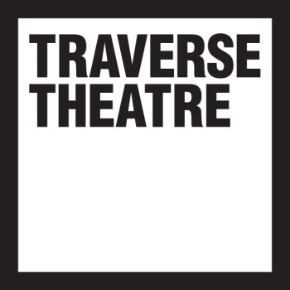

Visual Story
Traverse 1 Performance
Traverse Theatre

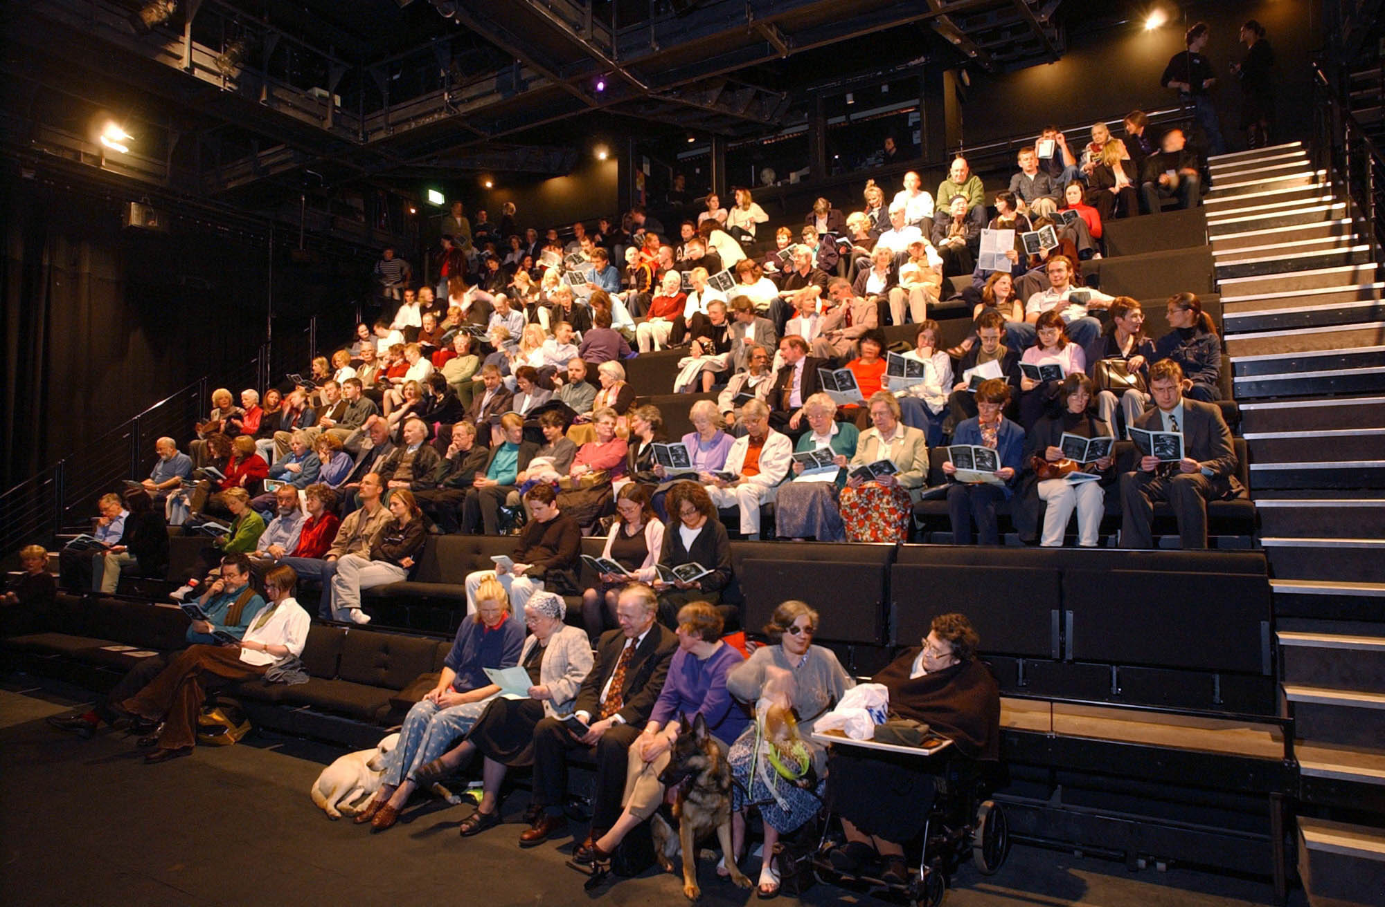

Notes on relaxed performance

We hope this guide will make your visit as easy and as enjoyable as possible. If you have any further questions, please get in touch.
Relaxed Performances are specifically designed to welcome people who prefer a more relaxed theatre setting – particularly customers with autistic spectrum conditions, learning disabilities or sensory and communication disorders. It is to give anyone who may feel excluded, the chance to experience live theatre in a less formal theatre environment and more supportive atmosphere, to reduce levels of anxiety. The theatre has unreserved seating but let us know if you have any specific needs during your visit.

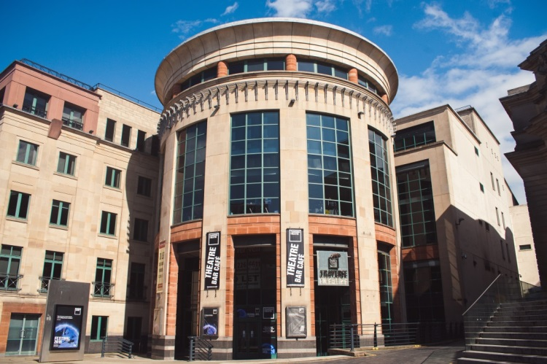
About your visit

This is the Traverse Theatre building from the outside. It is located at 10 Cambridge St, Edinburgh EH1 2ED

This is the view of the Traverse Theatre entrance from Cambridge St. There are two sets of automatic doors from the street into the Ground Floor Foyer, where the Box Office is situated. If you experience mobility challenges, please use the doors on the left where there is completely level access from the street.
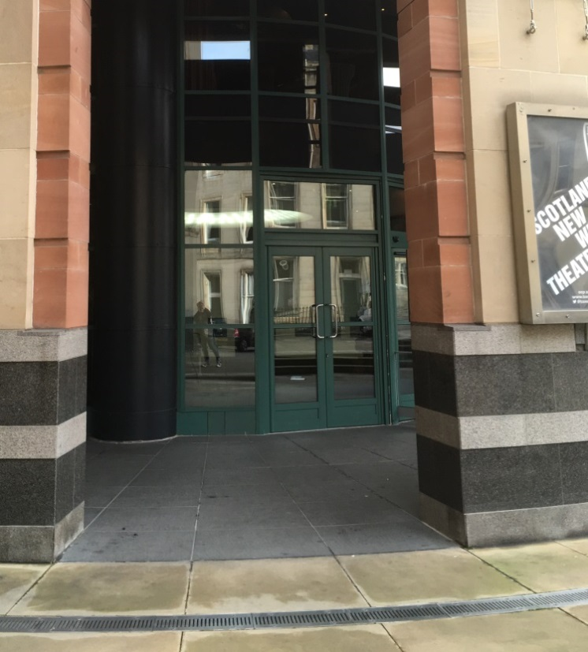

Once you have passed through the two sets of doors from the street, you will find the Box Office in front of you.

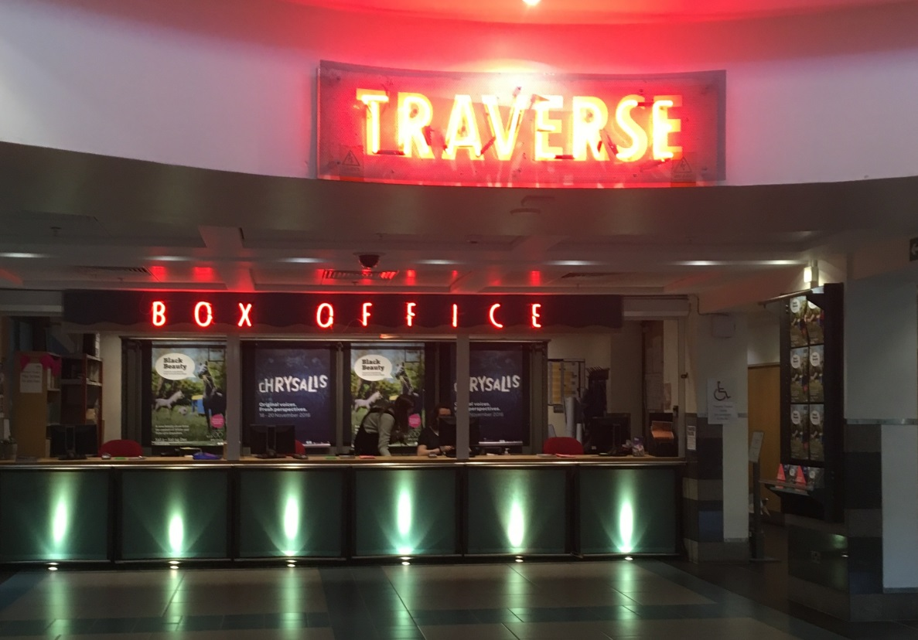

If you need to collect your tickets, you can do so from the large desk in front of you, where one of our Box Office Assistants will be able to help.

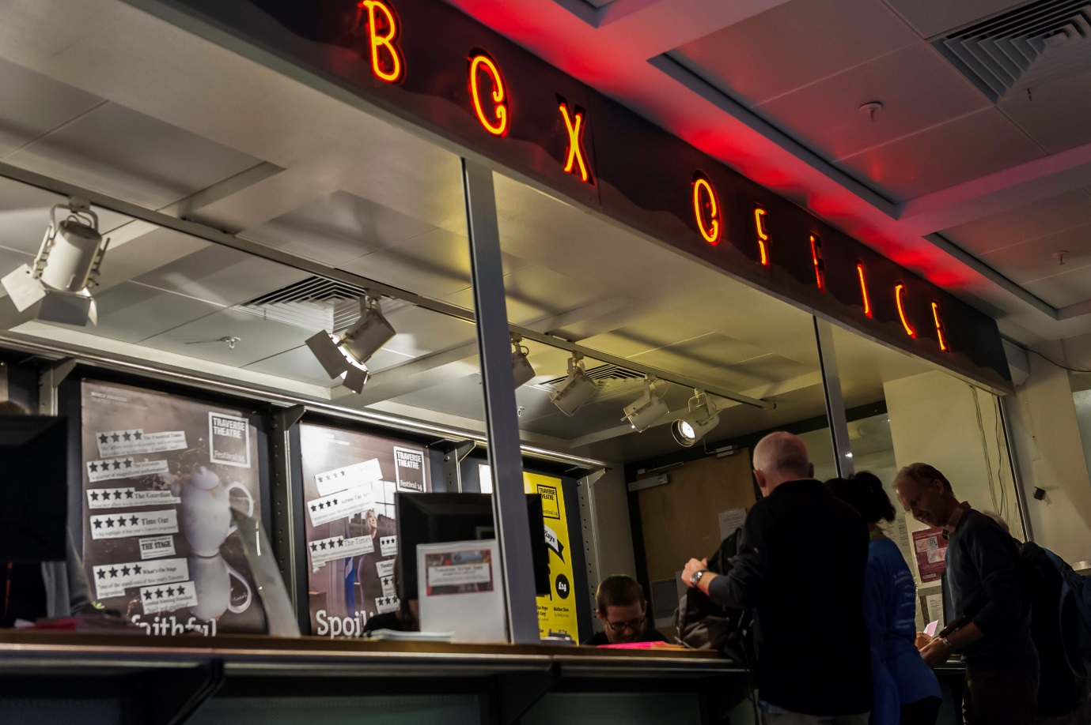

If you already have your tickets, you can go straight down to our Bar/Café area, which also serves as our Theatre Foyer.

You can access the Bar/Café, which is located on Level -1 of the building, area either by the lift, which is on your left if you are standing in the Box Office area…

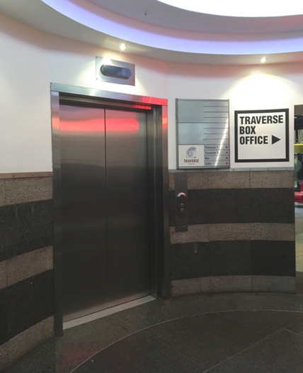

…or you can take the stairs on your right. Both the lift and stairs end in the same place.

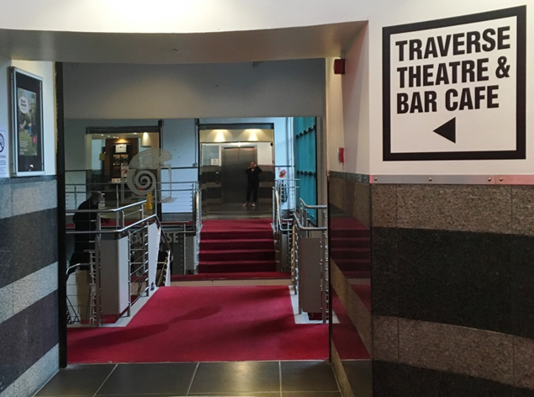

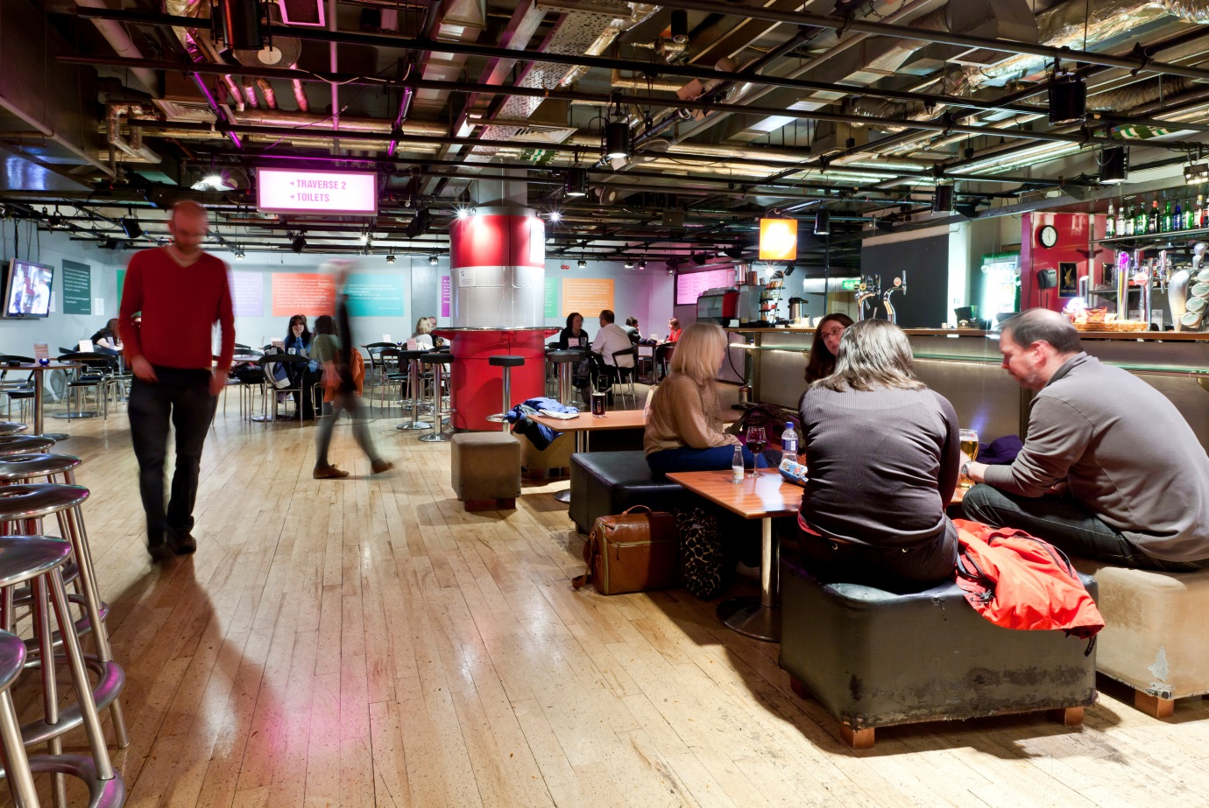
This is the Bar Café, which is located on Level -1. There are lots of tables and chairs, and some sofas, which you are free to use before and after the show, as well as at the interval. You do not need to buy any food or drink to use this space.

If you would like something to eat or drink, please go to the long bar on the right hand side of the room where one of our Bar Staff will be happy to help you. Food and drinks can be delivered to your table.

In the Bar Café the lights will be bright, there will be no music playing and the air conditioning will be switched off, so it is quieter.
Front of House staff in black t-shirts with yellow writing will be around and are happy to be asked questions.

If you follow the curved wall round to the television screen, the toilets and accessible toilet are on your left.

From the Bar/Café, to enter the theatre, you will need to go past the merchandise desk, which is located next to the bottom of the stairs.

If you require lift access please wait here and make yourself known to the Front of House staff who will accompany you to the theatre.

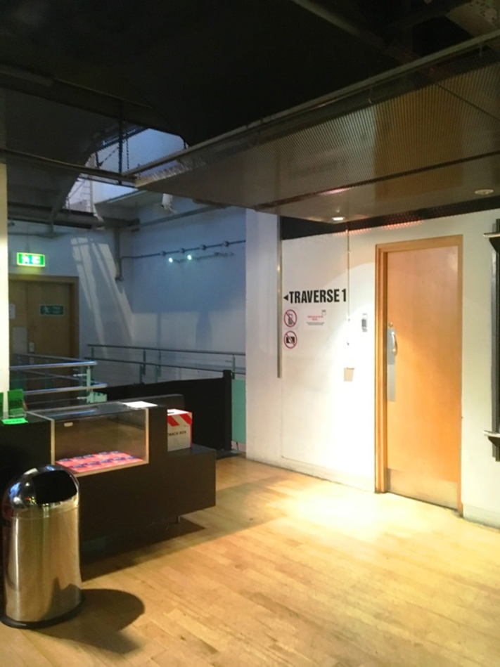

You will then be escorted to your seats by the Front of House Duty Manager.

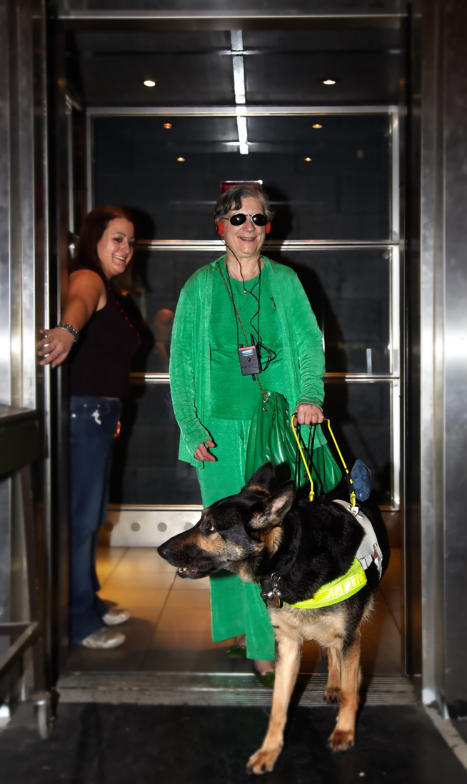

Once you get to the bottom there is a short walk along a corridor into the theatre.

This is the inside of the theatre where you will be watching the performance.

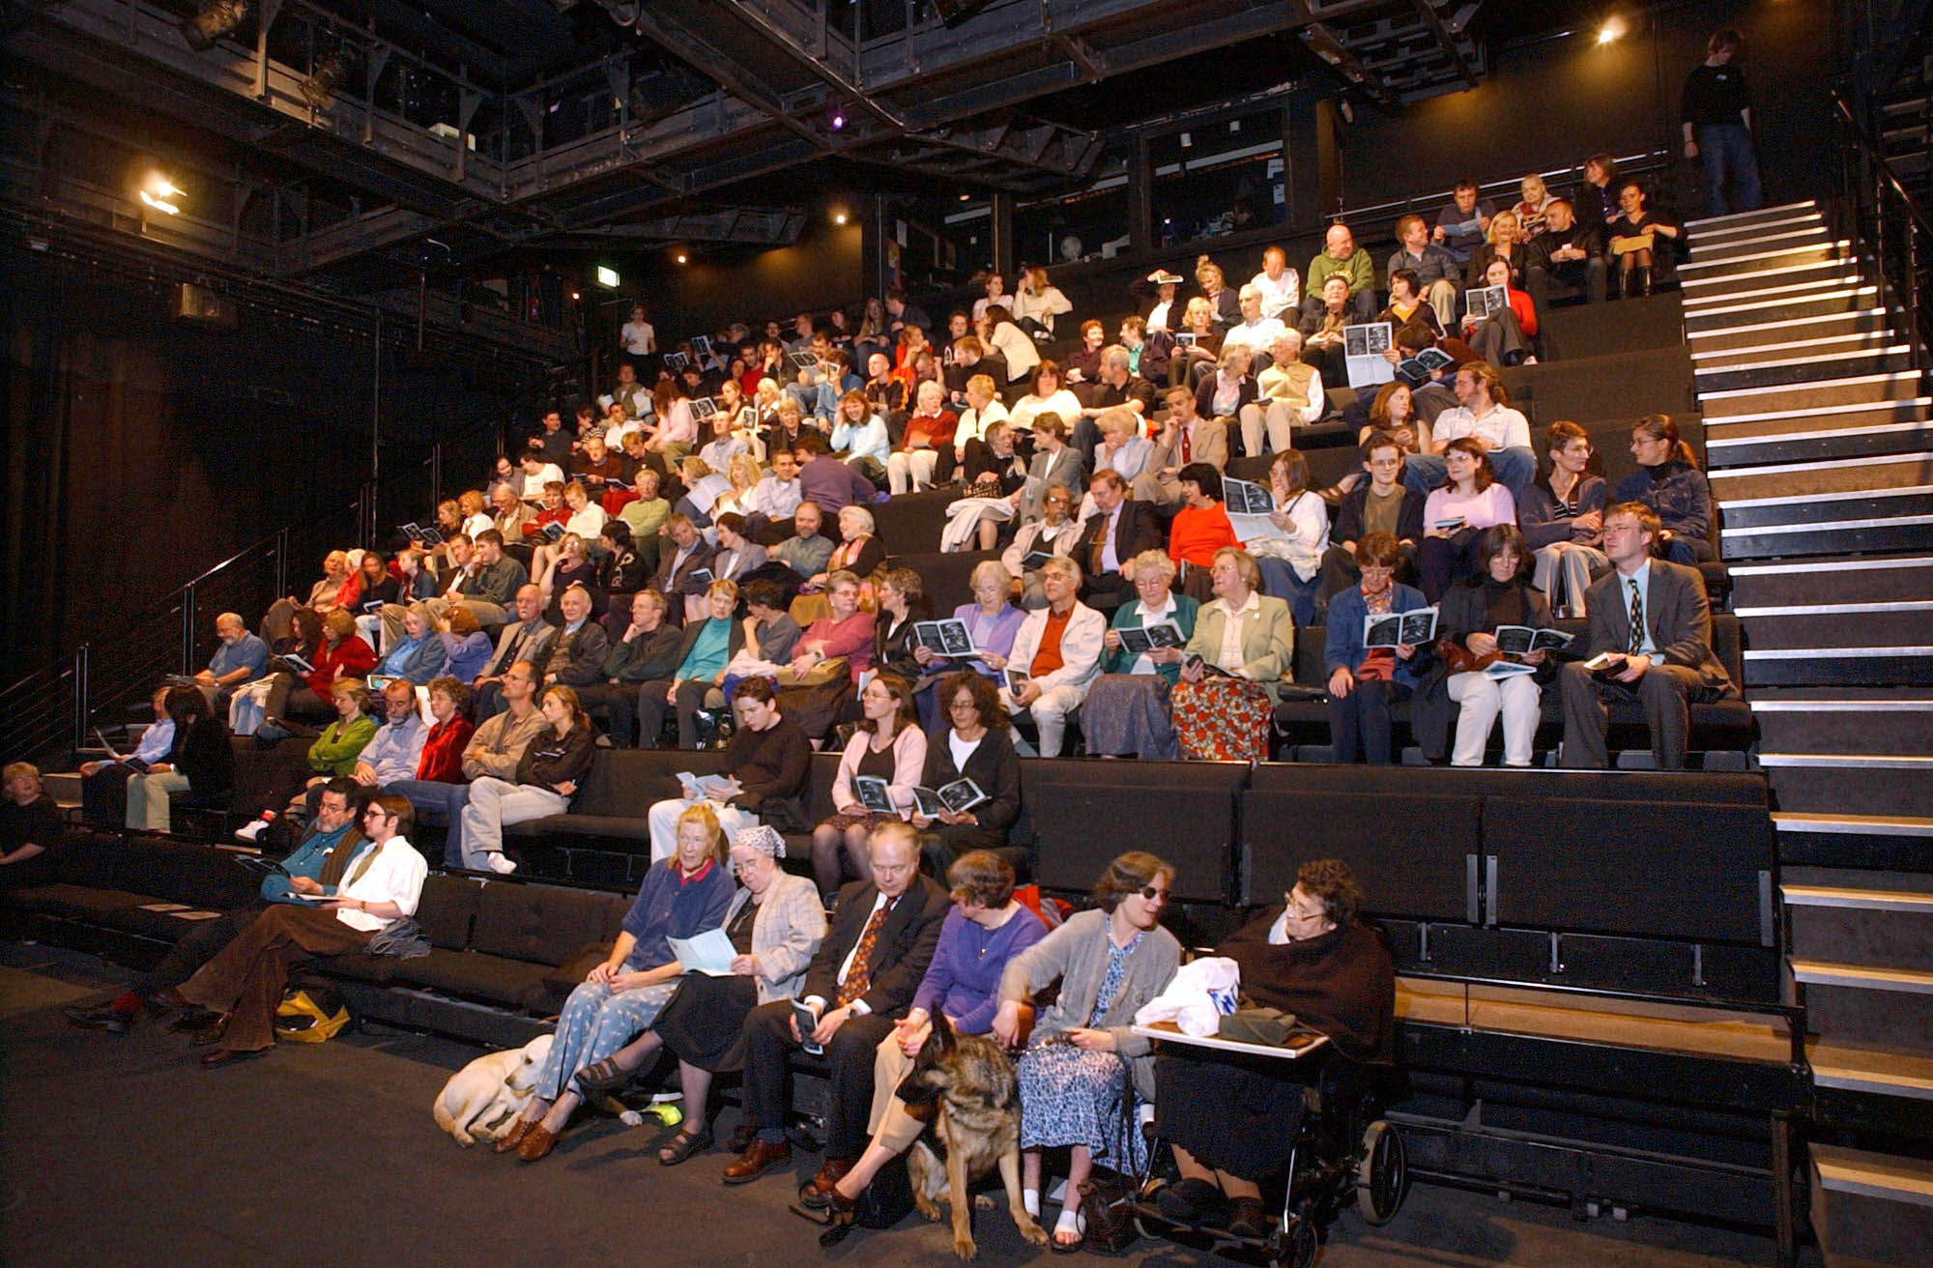

In the theatre, changes will also be made to effects in the show, such as lighting, smoke effects and sound levels in the show if any are particularly startling! There is a relaxed attitude to making noise and fewer seats will be sold so the audience have freedom of movement around the theatre.

During the performance the auditorium doors at the front of the theatre will remain open and there will be staff on hand in pink t-shirts. If you would like to take time out of the performance at any time, a member of staff will be available to take you to a nearby quiet area where there will be water & biscuits. There is a seated area outside the theatre at Stage Level between the lift and the theatre.

When the performance starts the lights will dim slightly but there will still be enough light to see. Our staff are on hand throughout the performance to assist, if there is anything they can do to help.
You can leave the theatre at any time during the performance and come back in anytime you like.

After the performance you will leave the same way you came in and can stay in the bar foyer area until you are ready to head home.

The Traverse Theatre is committed to providing relaxed performances in the future and we would welcome any feedback to improve our relaxed performances.

