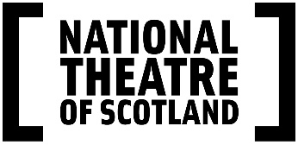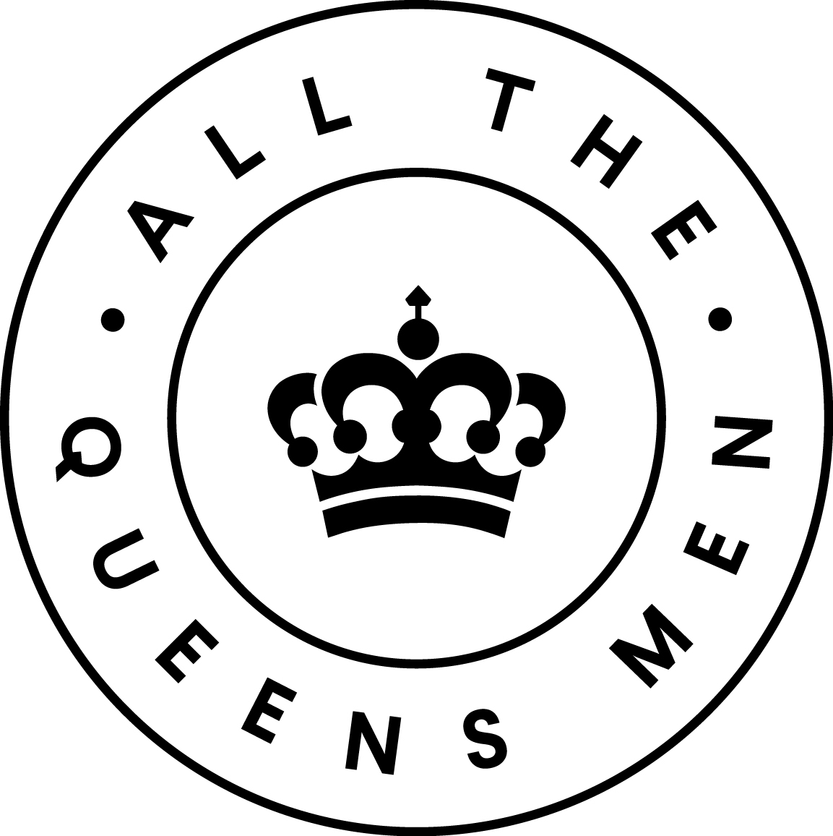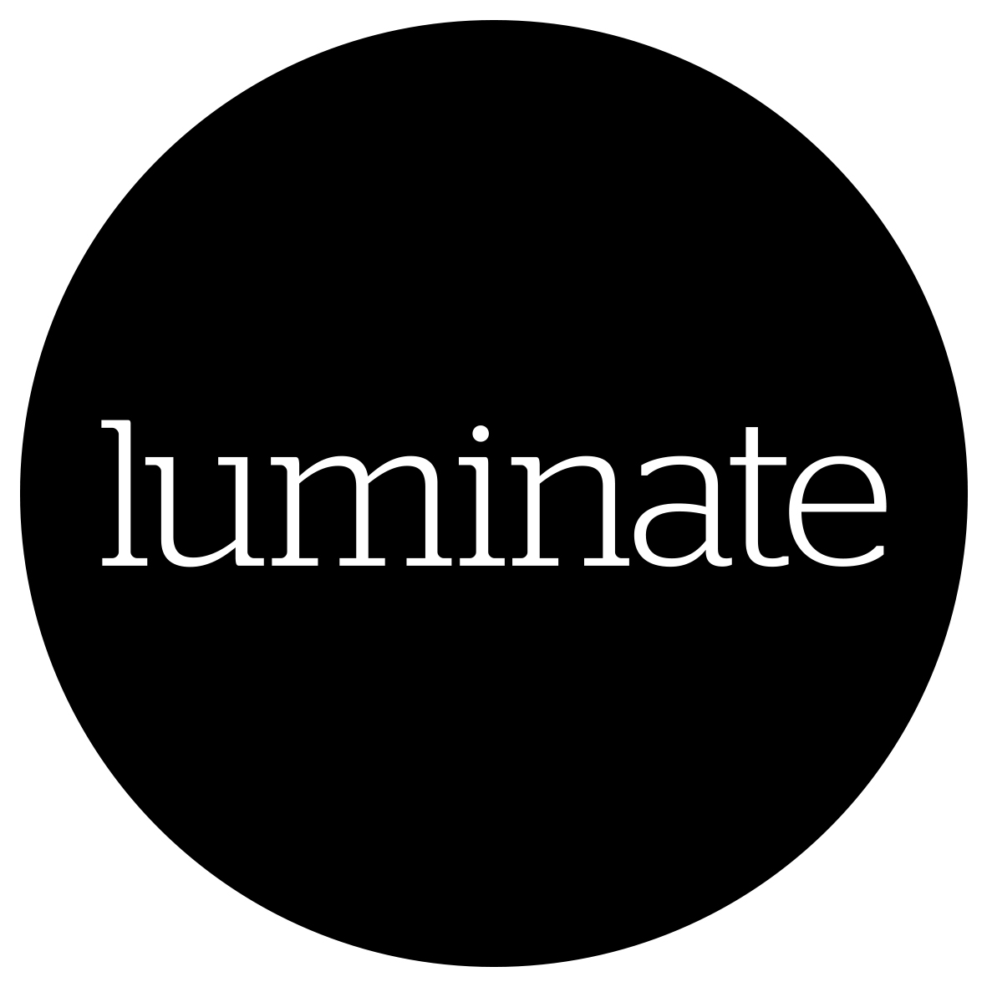

PRESS RELEASE: 9 March 2021

A National Theatre of Scotland and All The Queens Men co-production, in partnership with Eden Court and Luminate in association with Glasgow City Council.

The Coming Back Out Ball - a spectacular interactive digital event on Saturday 26 June 2021 - celebrating Lesbian, Gay, Bisexual, Trans and Gender Diverse, and Intersex Elders in Scotland.

Hosted online by Karen Dunbar and Jamie Rea with performances from Horse, Dean Atta and Jo Clifford and a contribution from Maggie Kinloch

Special ‘A Ball in a Box’ delivery for guests

National Theatre of Scotland Creative Lead: Lewis Hetherington
All The Queens Men Creative Leads: Tristan Meecham and Bec Reid

Designer CJ Mahony, Lighting Design Karen Bryce, Video and Animation Design Jamie Wardrop

Creative facilitators: Fraser MacLeod, Chris Stuart Wilson, Emma Jayne Park, Lou Brodie and Amy Watt

The Coming Back Out Ball is the spectacular culmination of monthly Social Dance Clubs for LGBTI+ Elders and allies which have been presented around Scotland and beyond since 2019, moving online in 2020. This unique interactive digital event invites all Social Dance Club participants, allies and the rainbow community to come together and celebrate LGBTI+ Elders across Scotland, UK and internationally.

The Coming Back Out Ball promises a fabulous evening of music, dancing, creativity and chat and is hosted online by Karen Dunbar and Jamie Rea. The event features performances from Scottish icon and long-time project supporter Horse as well as Dean Atta, sensational performance poet and Stonewall 2020 Book Award Winner, alongside legendary playwright Jo Clifford performing new writing inspired by her involvement in the project and a special contribution from Maggie Kinloch.

Ticketholders will receive a special ‘A Ball in a Box’ delivery in advance of the event, filled with surprises to ensure that everyone experiences a unique party atmosphere in their own living room.

The first Coming Back Out Ball and Social Dance Clubs were pioneered in Australia by arts organisation All The Queens Men. The Coming Back Out Ball project and Social Dance Clubs started in Scotland following discussions in which older members of the LGBTI+ community said they feared they may ‘return to the closet’ as they lose independence with age, particularly if needing to rely on carers or residential care. The project aims to strengthen the LGBTI+ over 50s community and promote their visibility and safety.

Social Dance Club participant said “So much of last evening pushed me to the boundaries of my emotions. The fact that I felt happy and secure in letting myself experience those emotions just shows how important being with you guys is for me”

The Social Dance Clubs in Scotland have created an ongoing friendly safe space for an under-represented community. The Coming Back Out Ball has been developed over the last two years by the Dance Club members and the creative team. The event will reflect and amplify the Elders’ voices and stories, celebrating memories and their dreams together for the future. There will be three Social Dance Clubs in the run up to the final event.

Lewis Hetherington, Creative Lead, The Coming Back Out Ball said “I feel so honoured to work on this project, with Scotland's incredible community of LGBTI+ Elders. From our first steps together at the first LGBTI+ Elders Social Dance Club in May 2019 to now, I have laughed, cried and been so inspired. I am so proud we've created a space where our Elders can step forward, in their own time, on their terms, to share their stories and express themselves.”

Tristan Meecham and Bec Reid, Artistic Directors, All The Queens Men said “It is a profound honour to be connecting older LGBTI+ and allied communities globally in this online space. Older LGBTI+ people across Australia and Scotland have been able to creatively and socially connect in regular, joyful, inclusive and dynamic Social Dance Clubs during times of immense disconnection. This partnership with National Theatre of Scotland, Eden Court, Luminate and Glasgow City Council has inspired universal, values led connections. All The Queens Men look forward to welcoming more and more beloved LGBTI+ Elders and allies into the global Dance Club family.”

James McKenzie-Blackman, CEO, Eden Court said “‘All of us at Eden Court have been greatly impacted by this special partnership with the National Theatre of Scotland, All The Queens Men and Luminate. The Social Dance Clubs have created a new space for LGBTI+ elders in the Highlands to meet, more recently digitally, to share stories, connect, debate and dance! We remain committed to further imbedding the project into the life of Eden Court, a building that proudly welcomes everyone, regardless of diversity or difference.”

Anne Gallacher, Director, Luminate, said “It’s been a privilege to share the journey of this project, and to connect with LGBTI+ elders across Scotland. The contribution they have made – and continue to make - to our society is huge. Older people have been disproportionately affected by the pandemic, and at this tough time we know that the social dance clubs have provided a welcome opportunity for LGBTI+ elders to feel part of a community, to connect with friends old and new, to feel safe, have fun, and learn something new along the way.”

The Coming Back Out Ball is presented in partnership with All The Queen’s Men, the Australian cultural participatory arts pioneers, alongside Eden Court and Luminate, Scotland’s creative ageing organisation, and in association with Glasgow City Council.

The National Theatre of Scotland Creative Lead on the project is Lewis Hetherington and for All The Queens Men, Artistic Directors Tristan Meecham and Bec Reid.

The LGBTI+ Social Dance Club events are led by creative practitioners Emma Jayne Park, Fraser MacLeod, Chris Stuart Wilson, Amy Watt and Lou Brodie.

Join the conversation: #comingbackoutball
comingbackoutball.com

The Coming Back Out Ball – Online

Saturday 26 June 2021, 7pm

Running Time: 3 hours

Tickets: £25 Includes ‘A Ball in a Box’ special delivery
On sale 12 noon,16 March 2021

Pay What You Wish advance booking for Dance Club members

Booking for the Ball will close two weeks in advance at 12 noon on 11 June 2021

Booking: https://www.nationaltheatrescotland.com/events/the-coming-back-out-ball

Access: Creative BSL event interpretation from host Jamie Rea

The LGBTI+ Elder Social Dance Clubs Online

The Dance Clubs continue till June 2021. They are free to attend on a drop-in basis. To book email: thecomingbackoutball@nationaltheatrescotland.com

Sunday 18 April 2pm – 3.30pm (BST)
Sunday 9 May 2pm – 3.30pm (BST)
Sunday 13 June 2pm – 3.30pm (BST)

nationaltheatrescotland.com

NATIONAL THEATRE OF SCOTLAND PRESS OFFICE CONTACTS:

Jane Hamilton – Media and Communications officer – jane.hamilton@nationaltheatrescotland.com
M: +44 (0)7967 742491

Emma Schad – Head of Communications – emma.schad@nationaltheatrescotland.com Tel: +44 (0)227 9016 M: +44 (0)7930 308018
Press Images: images available via dropbox
Artist Biographies

DEAN ATTA’s debut poetry collection, I Am Nobody's Nigger, was shortlisted for the Polari First Book Prize and his debut novel, The Black Flamingo, won the Stonewall Book Award. He was named as one of the most influential LGBT people in the UK by the Independent on Sunday. Dean’s work often deals with themes of gender, identity, race and growing up – and has appeared on BBC One, BBC Radio 4, BBC World Service, and Channel 4. Dean regularly performs across the UK, and internationally. He is a member of Malika's Poetry Kitchen. Dean is based in Glasgow, and is Co-director of the Scottish BAME Writers Network and a patron of LGBT+ History Month.

JO CLIFFORD is one of the generation of Scottish playwrights who put the Traverse on the international theatrical map in the late 1980s with her Losing Venice, Lucy’s Play, Playing with Fire, Ines de Castro and Light in the Village. With her Great Expectations she became the first openly trans playwright to have a play running in London’s West End. James McMillan wrote the music to transform her Ines de Castro into an opera (Scottish Opera/Edinburgh International Festival). Other work for the Edinburgh International Festival includes Schism in England (National Theatre of Great Britain), Anna (Traverse Theatre), Life Is A Dream (The Lyceum, Edinburgh) and Celestina (Birmingham Rep). Other translations and adaptations include Faust Parts 1 & 2 and Anna Karenina (both for The Lyceum, Edinburgh). Other theatre works includes The Tree of Knowledge (Traverse Theatre), Every One (The Lyceum, Edinburgh / Chris Goode and Co.). As a performer, Jo has previously worked with Chris Goode on his Albemarle Sketchbook (West Yorkshire Playhouse). Solo work includes her own God’s New Frock (Tron/Traverse) and The Gospel According To Jesus Queen of Heaven (Tron/Glasgay!). The Gospel… is currently touring Brazil in Portuguese and will tour Uruguay and Argentina in Spanish later this year.
Other work in 2017: The House of Bernarda Alba (Graeae and Royal Exchange); a new commission for the Royal Exchange; and War in America (The Attic Collective).
She is a proud father and grandmother.

KAREN DUNBAR is one of Scotland’s best-known comedy actors. She attended The Comedy Unit’s open auditions in 1997. The company immediately put her to work on their sketch show Chewin’ the Fat. She then went on to star in her own show, The Karen Dunbar Show, which received two coveted Golden Rose nominations for Best Comedy Show and Karen herself two personal nominations for Best Comedy Performance. Theatre work includes #71 (Oran Mor/Traverse Theatre), Shakespeare Trilogy (Donmar Warehouse), Witsherface: Funny How…? (Glasgow International Comedy Festival), Priscilla Queen of the Desert The Musical (David Ian Productions Ltd/Edinburgh Playhouse), Henry IV (Donmar Warehouse/St Ann’s Warehouse, New York), Cyrano De Bergerac (Edinburgh Book Festival/Communicado Theatre Co), Can’t Forget About You (Lyric Theatre, Belfast/Tron Theatre), Happy Days (Tron Theatre), The Guid Sisters (National Theatre of Scotland), Men Should Weep (National Theatre), Stand Up Drunk, A Drunk Woman Looks at the Thistle and Ha, Ha, Ha (Oran Mor) and The Vagina Monologues (Mark Goucher Productions).
Television work includes River City and An Audience With Burns (BBC Scotland), 2014 Commonwealth Games Opening Ceremony (Jack Morton Worldwide for BBC), MI High: Prison Break (Brown Eyed Boy), Happy Hollidays (Effingee Productions), Chewin’ the Fat and The Karen Dunbar Show (BBC Comedy Unit). Documentary projects include I Belong to Glasgow (Hopscotch Films for BBC) and When Karen Dunbar Met Denise Mina (Artworks Scotland for BBC Scotland).
Film projects include Mary Queen of Scots (Focus Features/Working Title) and Rice Paper Stars (Tartan Shorts).

LEWIS HETHERINGTON is an award-winning playwright and performance maker. His work is rooted in collaboration and storytelling. He is currently Creative Lead on The Coming Back Out Ball for the National Theatre of Scotland. Other National Theatre of Scotland work includes Rocket Post! He is an Associate of Playwrights’ Studio, Scotland, was recently IASH Creative Fellow for the University of Edinburgh and the Traverse Theatre, Embedded Artist for Creative Carbon Scotland, and Co-curator and Director on QWERK: a mini festival of new plays from Queer writers from all over the world, for fieldwork performance. Other credits include BOYS (The Pappy Show), The Secret Life of Suitcases (Unicorn) and Cloud Man both with Ailie Cohen Puppet Maker, Leaving Planet Earth (Grid Iron/EIF) Instructions for Butterfly Collectors, A Perfect Child and Sea Change (Oran Mor).As part of Analogue he won two Fringe Firsts and the Arches Brick Award for his work on Mile End, Beachy Head, 2401 Objects (with Oldenburg Staatstheater) and Stowaway. His work has toured extensively throughout Scotland the rest of the world including performances in Australia, Canada, China, Germany, Japan, Saudi Arabia, Singapore, and the USA.

HORSE is an iconic and utterly unique singer/songwriter, her voice described as 'a finely honed instrument', together with 'breathtaking stagecraft'. Her music is both moving and uplifting, the audience are totally absorbed whenever she performs. With a successful career expanding over three decades, she has opened and toured with various international artists, including Tina Turner, BB King, Bryan Ferry, Burt Bacarach. One of her best known songs Careful, was covered by Will Young. Her first record deal was with EMI/Capitol circa 1990. To date, she has released nine albums including The Same Sky and God's Home Movie. God's Home Movie on the MCA/Universal label. Her current album HOME was released on her own label Randan Records. In addition to writing and performing, Horse also produces work for other artists - sharing her immense expertise and experience. Horse’s unparalleled live performances showcase, not only her vocal range and the unique texture and tone that is virtually missing from today’s music, but also her relationship to her fans.

MAGGIE KINLOCH’s career has seen her travel all over the world, to over 35 countries, touring with productions and visiting drama schools to explore how theatre is taught the world over. As a director, a senior manager, a strategic leader, a teacher, a champion for equality and inclusion and a designer of theatre training, Maggie has created an international reputation. Maggie is Professor Emerita of Royal Conservatoire of Scotland, and won the Lifetime Achievement Award at the Scottish Higher Education Awards in 2014, the Inspiration Award at the Proud Scotland Awards in 2019 and the Lord Provosts of Glasgow’s Gold Medal for services to the cultural life of the city in 2011. She was appointed as one of the first ever members of the Board of Directors of the National Theatre of Scotland at its inception, and served a full eight-year term. She is currently part of the team at NTS who are working on The Coming Out Again Ball project.

TRISTAN MEECHAM is a Queer artist and performer and together with Bec Reid, he is the Artistic Director of All The Queens Men. Tristan has become a leading creative voice within the LGBTI+ community nationally and internationally, specifically for championing the rights of LGBTI+ older people. All The Queens Men projects are presented by leading cultural institutions around the world including: Ansan Street Arts Festival (South Korea), ANTI Contemporary Arts Festival (Finland), Arts Centre Melbourne, Arts House (Melbourne), Bleach Festival (Gold Coast), Brisbane Festival, Darwin Festival, Sydney Festival, National Theatre of Scotland / Luminate Festival / Eden Court, Taipei Arts Festival, Salisbury International Arts Festival and West Kowloon Cultural District (Hong Kong). Recent projects include: The Coming Back Out Ball, a spectacular social event celebrating Lesbian, Gay, Bisexual, Transgender and Intersex (LGBTI+) elders; LGBTI+ Elders Dance Club, a free monthly social event for rainbow communities; Congress, a citizens’ assembly in which community collaborate with wordsmiths to create political first speeches; Fun Run, a riotous performance spectacle in Tristan runs a marathon on a treadmill live on stage supported by hundreds of local community performers; and Toy, a gender neutral workshop where children build toys of their dreams. Tristan has also worked as Creative Director of the 2020 Victorian Seniors Festival, a 26-week online festival featuring over 150+ older artists from around Australia and Festival Director of Give it up for Margaret!, a month-long festival which explored the current status of arts philanthropy on the centenary of the birth of arts philanthropist Margaret Lawrence.

JAMIE REA is a multidisciplinary artist and deaf performer, visual artist; raised in Northern Ireland and living in Glasgow since 2015. His first language is BSL. He was a member of the first cohort of students in the RCS BA Performance in BSL and English, graduated in 2018. He has collaborated with cultural organisations across Scotland Including Electric Creative, NTS, BUZZCUT, Take Me Somewhere, Solar Bear and Raw Material; Across England including Deafinitely and FUEL. He is also a BSL consultant including embedding access, hosting and promotion, workshop leader. In 2020, he collaborated with Shoot Your Shot, the Pride fundraiser. He wanted to show the unique talents of Deaf artists and performers and raise awareness in theatre industries. Jamie wanted to deepen existing skills to build new festivals and artist development structures to advocate for deaf artists in Scotland as for 2021 he will be in Take Me Somewhere team on producing placement for 2021 Festival.

BEC REID is an Australian based performer, producer, director, choreographer and engagement specialist. Bec encourages people to see their world in new ways through highly physical, participatory, practical, collaborative and celebratory actions. For more than 20 years, Bec has passionately worked in the space where professional artists and communities of interest meet; collaborating with communities and artists nationally and internationally. Together with Tristan Meecham, Bec leads All The Queens Men, is a founding member of Everybody Now! with Kate McDonald and Ian Pidd and regularly collaborates with acclaimed artists Madeline Flynn and Tim Humphrey. In 2017-18, Bec was a Fellowship recipient from the Australia Council for the Arts. Bec has continually served on arts boards and regularly mentors young and emerging artists formally and informally.

Notes to Editors

The National Theatre of Scotland is dedicated to playing the great stages, arts centres, village halls, schools and site-specific locations of Scotland, the UK and internationally. As well as creating ground-breaking productions and working with the most talented theatre-makers, the National Theatre of Scotland produces significant community engagement projects, innovates digitally and works constantly to develop new talent. Central to this is finding pioneering ways to reach current and new audiences and to encourage people’s full participation in the Company’s work. With no performance building of its own, the Company works with existing and new venues and companies to create and tour theatre of the highest quality. Founded in 2006, the Company, in its short life, has become a globally significant theatrical player, with an extensive repertoire of award-winning work. The National Theatre of Scotland is supported by the Scottish Government. www.nationaltheatrescotland.com

All The Queens Men is an Australian independent arts organisation founded by award-winning performance artists Tristan Meecham and Bec Reid. ATQM collaborate with communities of all shapes, sizes, and identities to produce transformative creative experiences that champion equality, social health, and human connection. ATQM values radical optimism, pride, activism, generosity and respect. With over 30 years of combined experience in community committed arts practice All The Queens Men has presented leading large-scale community projects locally, nationally and internationally including at Ansan Arts Festival (South Korea), ANTI Contemporary Arts Festival (Finland), Arts Centre Melbourne, Art House (Melbourne), Bleach Festival (Gold Coast), City of Melbourne, Darwin Festival, Galway 2020 European Capital of Culture, National Theatre of Scotland/ Eden Court Theatre / Luminate Festival (UK), Next Wave Festival (Melbourne), Sydney Festival, Taipei Arts Festival (Taiwan) and West Kowloon Cultural Arts District (Hong Kong) amongst many others.
www.allthequeensmen.net // www.comingbackoutball.com
Eden Court is the largest multi-arts venue in Scotland housing two theatres, two art-house cinemas, two dance studios, three visual art galleries and conference and meeting spaces. Eden Court’s home, on the banks of the River Ness, is a nationally unique, grade-A listed building, spanning three centuries. It presents approximately 450 live performances and 2,000 film screening every year as well as 60 community classes a week. This activity attracts an audience of over 300,000 people every year. Eden Court runs one of the largest creative learning programmes of any UK theatre. As well as the extensive programme of weekly classes it is also the only theatre in Scotland to offer Scottish Qualifications Authority (SQA) courses in Drama and Dance. Pupils from across the Highlands have the opportunity to study at Eden Court for an SQA Higher or National 5 Dance or Drama qualification. Eden Court is also the Scottish Government’s partner for Cashback for Creativity where seized criminal assets are redistributed to provide meaningful activity for young people at risk. Eden Court is a registered charity and is grateful to receive regular funding from Creative Scotland and the Highland Council.

Luminate is Scotland’s creative ageing organisation, which was established in 2012 and aims to ensure that older people in Scotland have the opportunity to take part in high quality arts and creative activities, whatever their background and circumstances and wherever they live. The organisation supports older people as artists, participants and audiences; nurtures skills development in artists of all ages who wish to work with older people; researches, develops and tests new models of creative practice; and challenges stereotypes of ageing through their public facing work. They are leaders in the field of creative ageing, advocating for the place of older people in Scotland’s cultural life and sharing good practice nationally and internationally. Luminate’s work with LGBTI+ elders - in collaboration with LGBT Health & Wellbeing - has led to successful cabaret events in Glasgow and Edinburgh in 2017, and the creation of a film entitled Return to the Closet? that explores older LGBTI+ people’s views and experiences of care services in Scotland. www.luminatescotland.org

