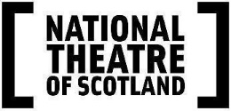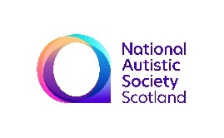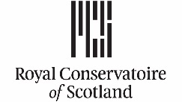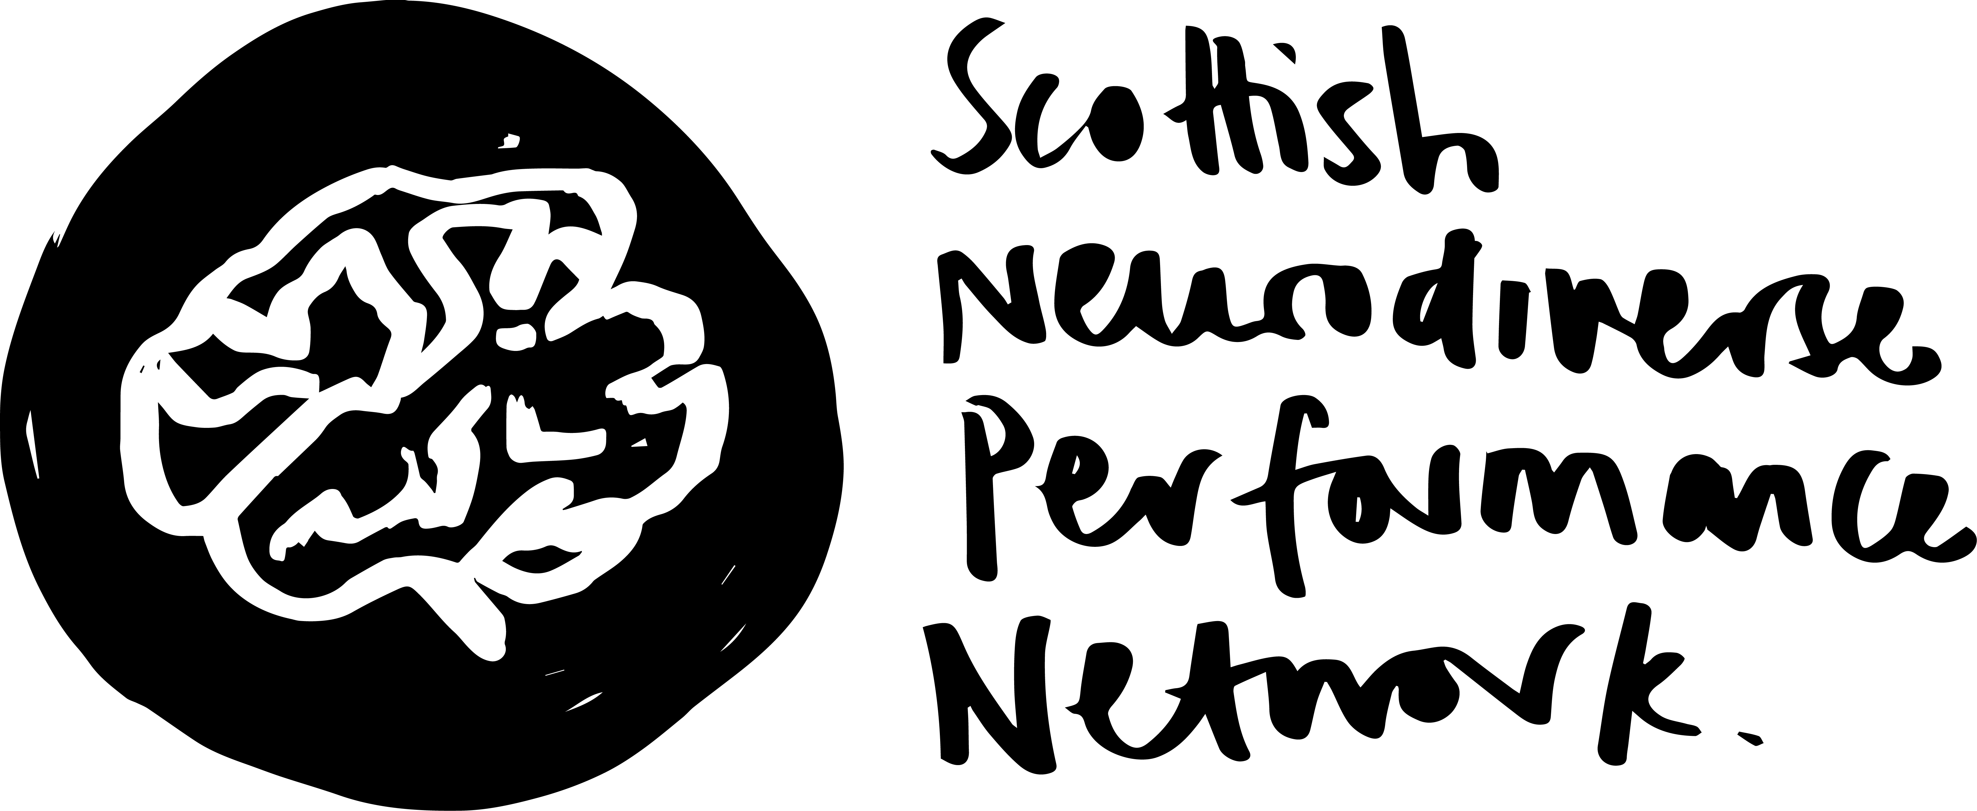

Press Release – 02 September 2021

NEUROSTAGES

15 & 16 October 2021 - online and at the CCA, Glasgow

A two-day festival of workshops, provocations, discussions, and performances curated by the Scottish Neurodiverse Performance Network (SNPN).

A hybrid festival – with a full online programme and events streamed live from the CCA in Glasgow and opportunities for in person attendance.

The programme includes two days of performances, film, workshops and discussions, online and in person. On the first day, renowned neurodivergent artist, Jess Thom of Touretteshero will offer a keynote presentation Disability Culture in a Time of Pandemic and the festival will be rounded off with a special evening of short performances from local neurodivergent artists, performed live at the CCA, hosted by Ivor MacAskill and Sanjay Lago.

NEUROSTAGES is a neurodivergent-led platform and space for artists and creatives, communities, individuals and industry professionals to find out more about either neurodiversity or performance. The NEUROSTAGES festival explores neurodivergent-made pathways, practices of solidarity and the potentialities of futuristic thinking in performance. It asks how can embracing neurodiversity change theatre and performance for the better? It is an invitation to join neurodivergent performers and artists to share perspectives, experiences and practices. It is an opportunity to enjoy new film work, to hear about the creative processes of the artists supported by the NEUROSTAGES mentorship opportunity, to physically delve into facilitated workshops and to celebrate a constellation of neurodivergent artistry from Scotland and beyond.

NEUROSTAGES is curated by Aby Watson and Rachel Clive, on behalf of SNPN and is hosted by Aby Watson, Rachel Clive and Ivor MacAskill. Aby Watson is an artist, disabled dance maker, performer, and researcher, Rachel Clive is a neurodivergent theatre practitioner, researcher, and teacher/facilitator and Ivor MacAskill (he/they) is a queer, trans, neurodivergent live artist and theatre-maker based in Glasgow.

NEUROSTAGES is delivered by the National Theatre of Scotland and SNPN, in partnership with the Royal Conservatoire of Scotland and National Autistic Society Scotland. Both the festival and SNPN have been generously supported and hosted by the CCA.

NEUROSTAGES marks the final phase of Limitless, a project that explores a framework for the engagement of autistic people in creative activity as artists, audiences and participants http://www.limitlesspilot.co.uk/

The programme involves work from a host of performers, companies and facilitators including: Jess Thom (Touretteshero); Ivor MacAskill; Euan Hayton, Chloe Maxwell, Alison Mackenzie and Hughie McIntyre (not panicky); Sean Logan; Morna McGeoch, Jonathan Carlton and Andrew Robertson (BoP Young Artists); Emma McCaffrey (Lung Ha/Reluctant Penguin Productions); Liselle Terret and Emma Selwyn (Not Your Circus Dogs Collective);; Akshayee Shetty (Sense Kaleidoscopes); Anne Kjaer; Neha Apsara; Steven Fraser; Heather Andrews; Susanna Dye; Jo Hauge; Leonie Rae Gasson; Sanjay Lago; Indra Wilson; Lesley Howard and Clare Adam; Rylan Gleave; Simone Seales; Hannah Yahya Hassan and Andrew Gallagher.

Rylan Gleave, Simone Seales, Hannah Yayha Hassan and Andrew Gallagher are the four mentees who successfully applied for a development opportunity with the festival and will be sharing the outcomes of their mentorship at NEUROSTAGES.

Films include Harmonic Spectrum - produced and directed by Austen McCowan & Will Hewitt; Yearning: A Letter to Mum – concept and production by Neha Apsara; If You Could Touch Me Now - concept and production by Anne Kjær, performed by Robert Softley Gale and Anne Kjær; What it Feels Like by Steven Fraser.

Nick Ward, Director of National Autistic Society Scotland said:
“We’re really excited to partner with National Theatre Scotland and the Royal Conservatoire of Scotland on the ‘NEUROSTAGES festival’. Despite there being 56,000 autistic people in Scotland, opportunities for autistic artists can be few and far between leading to their stories and experiences being on the margins of the creative industries. NEUROSTAGES offers a wonderful opportunity to address this by allowing autistic and other neurodivergent artists to connect, develop and perform.”
Jesse Paul, Fair Access Manager at the Royal Conservatoire of Scotland is thrilled to see the launch of the NEUROSTAGES festival, the first of its kind in Scotland.
“This festival is a rich collaboration between the Royal Conservatoire of Scotland, National Theatre of Scotland and the National Autistic Society which explores, tests and develops the potential of a creative autistic life. We are excited about the good practice that has been co-developed for supporting neurodiversity in performance from a participant, audience and practitioner perspective.
The NEUROSTAGES Festival models a best-practice, progressive and logical step forwards and we are delighted to see the opportunities it has created for people from the performance community who identify as neurodiverse, as well as for those interested in the discourse around neurodiversity.”

Aby Watson and Rachel Clive, SNPN said:
“The Scottish Neurodiverse Performance Network (SNPN) was started in 2019 as a space for neurodivergent-identifying artists working in performance in Scotland to make connections and share projects, practice, advice, support and solidarity. SNPN is thrilled to be curating NEUROSTAGES, and to be able to grow, learn, welcome new members and offer opportunities that creatively nourish and develop the practices of its artist network in partnership with NTS, RCS and NAS. NEUROSTAGES is an exciting opportunity to gather, centre and platform neurodivergent talent, artistry and creativity - in a way that is yet to be seen in Scotland. It is an essential opportunity for the Scottish performance sector to engage in neurodivergent-led discussion on how the industry can better support neurodivergent artists. We are very grateful to the CCA for its continued support as host organisation.”

Full programme to be announced/go on sale on Thursday 23 September

Dates: 15 & 16 October 2021
Times: 10 am - 6pm
Booking: one pass for the full online festival at streamed from the CCA www.nationaltheatrescotland.com/neurostages
Passes are available on a Pay What You Wish scale from £0 to £20.
Tickets for the limited capacity in person events at the CCA will go on sale on Thursday 23 September at 3pm.

Access: The CCA is wheelchair accessible. All live and online events will be autism friendly. All online events will be captioned. BSL and Audio description for live and online events to be confirmed. An easy- to-read festival guide, audio introduction and visual guide
for the venue will also be made available by end of September.

IMAGES available in dropbox here

NATIONAL THEATRE OF SCOTLAND PRESS OFFICE CONTACTS:

Jane Hamilton – Media and Communications officer – jane.hamilton@nationaltheatrescotland.com
M: +44 (0)7967 742491

Emma Schad – Head of Communications – emma.schad@nationaltheatrescotland.com
Tel: +44 (0)227 9016 M: +44 (0)7930 308018

Please do get in contact with any image/interview requests.

ARTIST BIOGS

Neha Apsara - based in Glasgow. Neha’s identity as a second-generation British Indian, ex-Muslim, neurodivergent, queer woman, plays an important part in her work as an artist. Using a wide range of mixed media, including photography, text, moving image, sound textiles, and environmental installations she explores themes such as bodily memory, the female form, and sexuality in relation to ideas of modesty, religious control, and cultural and colonial constraints.

Rachel Clive is a neurodivergent theatre practitioner, researcher and teacher/facilitator. After doing a Masters at the Royal Conservatoire of Scotland she set up Tramway Theatre Arts Group, an ensemble dedicated to working performatively with and through neurological differences. She helped to found Citizens' Theatre Friday Club, an ensemble of learning-disabled actors, and Saturday Citz, a theatre group for learning-disabled young people who are serious about acting. She has recently completed a theatre practice-based PhD at the University of Glasgow. The PhD initiated The Panarchy Projects, a series of participatory performance projects with neurodivergent performers from across Central Scotland. These projects explored how we perform (and might perform) with rivers and estuaries in the context of a rapidly changing climate

Steven Fraser is an animator, artist and writer who creates short films, comics, zines, performances and installations. Steven makes inventive use of animation, illustration, puppetry and kinetic art to present unique and interesting stories. Steven identifies as queer and autistic and his animation and performance work has been screened and staged at many international film and arts festivals.

Andrew Gallagher (He/Him) is an Actor, Writer and Disability/Autism Advocate.
He graduated with an BA in Drama and Performance from Inverness College UHI.
Based in Inverness, he travels around the country adding his oddball charm to a variety of projects. Performance Credits include “Hacks for the future” with National Theatres Futureproof Festival and “Act of Repair” with Scottish Youth Theatre.
Writing Credits include "2020 Stories Pt2" for SYT and The Traverse Young Writers Group 2021

Rylan Gleave (b.1997) is a Glasgow-based composer and vocalist whose music addresses intersectional identity, re-contextualised natural situations, and quiet, furious resistance. His musical practice is inclusive, and involves mending the unfeigned gaps in his classical study with the healings of imaginative neuro-/ gender-divergent kinship. Re-emerging as a composer/performer, Rylan’s work explores the instrumentalqualities of his late-breaking trans-masc voice through queer autoethnography, and autistic-specific notation. His music has been praised as ‘haunting’ by The Herald, and ‘rapturous’ by The Scotsman, who named him ‘One to Watch’ 2021, describing him as ‘one of the brightest lights in Scotland’s new music scene’. Rylan has recently graduated from an MMus Degree with Dr. Linda Buckley at the Royal Conservatoire of Scotland, with the Royal Conservatoire of Scotland Composition prize, after completing his BMus with David Fennessy, graduating with Honours of the First Class, The Dinah and Walter Wolfe Memorial Award, and The Kimie Composition Prize. Website; www.rylangleave.com
Sanjay Lago is a Scottish Indian Neurodiverse Actor, Writer and Facilitator for the last 10 years. Trained at the Royal Conservatoire of Scotland, Sanjay has always been passioante about real voices and new stories. His practice mainly consists of autobiographical writing and working in a socially engaged practice. He has experience of working in schools, hospices and prisons and enjoys devising theatre. His work looks at themes of Race, belonging, dyslexia, masculinity and mental health to name a few. He is also a strong advocate for Diversity in the Arts, pushing for future generations to see more people like themselves on our stges and screens, something he feels he lacked growing up in Scotland. He has recently completed his time on the Soho Theatre Writers Lab, writing his first full play, "Jalebi", and is now writing his next one that was thought of during the writers lab. He practice consists of autobiographical and devising theatre. He has experience of working in different communities and with various theatre companies.He has had writing published in zines and online blogs. He is published by the Scottish BAME Writers Network and Two Destination Language. He has worked with companies including: National Theatre of Scotland, Tamasha Theatre, Persistent & Nasty, Mischief Las Bas and Space Arts UK to name a few. He more recently was announced as one of the new trainee artists for Imaginate. In the free time Sanjay does get, he enjoys reading, writing poetry and watching Doctor Who."

not panicky performers Euan Hayton, Chloe Maxwell, Hughie McIntyre and Alison Mackenzie came together to collaborate with Rachel Clive on an ecological performance as research project at the University of Glasgow. not panicky was performed live at the James Arnott Theatre between the first and second COVID-19 lockdowns in 2020. The intermedial and dialogic performance piece explored how developing performative relationships with our living environments can help us manage our climate (and other) anxieties, and intervene in ableist/anthropocentric narratives about autism, learning disability and environmentalism

Simone Seales originally from Florida, is a Glasgow-based cellist who completed their postgraduate studies at the Royal Conservatoire of Scotland in 2021. They focus on free improvisation (both tonal and atonal) and devising music for theatre. Simone is passionate about exploring sound, how sound can reflect emotional states of being and how emotions are embodied. Their creative influences come from Black feminist leaders such as Audre Lorde, Assata Shakur and Angela Davis. Within Simone's creative work, they centre Blackness, sexuality, intersectional feminism and anti-racism. They believe Western Classical musicians are capable of making meaningful social change. Passionate about reaching new audiences and increasing access to arts education, Simone is a Lead Ambassador for the Benedetti Foundation, and focuses on trauma-informed teaching practices. Website: https://simoneseales.com

Susanna (she/they) works between the fields of theatre, dance and film, exploring how movement and the body are encountered both live, and digitally. Being dyspraxic and dyslexic, Susanna has developed an inclusive practice as a facilitator, teacher and choreographer, that is built on movement as a field for individuality and play, making work through exploring the creative potential of neurodivergence and difference.
Susanna is curious about developing an approach to dance that is guided by the senses, exploring habitual movement patterns and how the body self regulates through movement. This research has been awarded funding by Arts Council England, and is supported through residencies at The Place, Wellcome Collection and Siobhan Davies Studios

Aby Watson is an artist, disabled dance maker, performer, and researcher based in Glasgow, Scotland. Her performance practice is an expression of the neurodivergent energy and embodiment of her dyslexic, dyspraxic and ADHD mind-body. Through the use of movement, choreography, text, and object, Aby's works agitates the tensions between virtuosity and the pedestrian, beauty and the grotesque, the silly and the serious. Her solo work has been seen at venues The Southbank Centre, Sophiensaele, Tramway and Wales Millennium Centre, amongst others. Aby strives to challenge exclusive neuronormative values in dance, as well as celebrate the creative potential of neurodivergent authorship and visibility in performance. In late 2019, she founded the Scottish Neurodiverse Performance Network, a space for neurodivergent artists to make connections and share projects, practice, advice, support and solidarity. Aby is currently undergoing her PhD at The Royal Conservatoire of Scotland, titled 'Disordering Dance', which practically interrogates dance making from a lived experience of dyspraxia and neurodivergence. www.abywatson.co.uk / www.disorderingdance.com

NOTES TO EDITORS:
The National Theatre of Scotland is dedicated to playing the great stages, arts centres, village halls, schools and site-specific locations of Scotland, the UK and internationally. As well as creating ground-breaking productions and working with the most talented theatre-makers, the National Theatre of Scotland produces significant community engagement projects, innovates digitally and works constantly to develop new talent. Central to this is finding pioneering ways to reach current and new audiences and to encourage people’s full participation in the Company’s work. With no performance building of its own, the Company works with existing and new venues and companies to create and tour theatre of the highest quality. Founded in 2006, the Company, in its short life, has become a globally significant theatrical player, with an extensive repertoire of award-winning work. The National Theatre of Scotland is supported by the Scottish Government. www.nationaltheatrescotland.com

The National Autistic Society Scotland is a leading charity for autistic people in Scotland and their families. We provide a range of services and support for Scotland’s 56,000 autistic people and their families. We also campaign at national and local level to help create a society that works for autistic people. www.autism.org.uk/Scotland

ROYAL CONSERVATOIRE OF SCOTLAND: LIKE NOWHERE ELSE
- Established in 1847. In 2022, RCS will celebrate its 175th anniversary
- Specialist teaching across music, drama, dance, production, film and education
- The Royal Conservatoire of Scotland is a world top three destination to study the performing arts (QS World University Rankings 2021)
- More than 1200 students from more than 60 countries
- Partnerships with national artistic companies
- One of Scotland’s busiest arts venues in 600+ performances each year (pre-pandemic)
- More than 3,000 students are taught every year through the Junior Conservatoire and Short Courses, as well as national Fair Access programmes
- Download the prospectus
- · Support the future of the arts through the We are Still Here student scholarship campaign

